

**A PROJECT REPORT FOR SECURE IoT CLOUD INTEGRATION ARCHITECTURE FOR MOBILE PAYMENTS**

Name: Simon Wachira Wairimu

Registration NO: CSE/18

Mobile NO: 0726992826

Email: [wachirasimon816@gmail.com](mailto:wachirasimon816@gmail.com)

Examination: CISSE

Examination Sitting: December 2024

Supervisor: MR. FRED ODHIAMBO

A project report submitted in partial fulfilment of the award of **Certified Information Systems Solutions Expert(CISSE)**

# DECLARATION

I hereby declare that I am the sole author of this project report. To the best of my knowledge, this report contains no material previously published or written by any other person, except where due acknowledgment has been made. This report also contains no material that has been submitted as part of the requirements for any other academic or non-academic program. This work has been completed in strict adherence to the guidelines and regulations of KASNEB.

Date: …………………...... Signature: ………………………...

# ACKNOWLEDGEMENT

# 

I would like to take this opportunity to express my deepest gratitude to everyone who supported me, both directly and indirectly, throughout this project.

First and foremost, I thank God for blessing me with good health and strength during this journey.

A special and heartfelt appreciation goes to Francis K. Kagai, whose encouragement and unwavering support were instrumental in keeping me focused and motivated. Your belief in me was a driving force behind my success, and for that, I am sincerely grateful.

I also extend my warm thanks to Michael Njeru, Maureen Wairimu, Lilian Mbaluka, and Madam Sharon. Your cheerful conversations and support helped me navigate the most challenging days with a smile.

To Mr. Fred Odhiambo, thank you for your guidance and supervision. Your expertise and insights were invaluable in shaping this project and ensuring its success.

This journey has been one of incredible growth and learning, particularly in the field of the Internet of Things. I am truly grateful to everyone who contributed to making this experience fulfilling and memorable.

# LIST OF ABBREVIATIONS

TLS - Transport Layer Security

AWS -Amazon Web Service

AWS EC2 - Amazon Web Services Elastic Compute Cloud

IoT – Internet of Things

bcrypt - Blowfish encryption

MQTT - Message Queuing Telemetry Transport

ESP32 - Espressif Systems 32

HTML – Hypertext Markup Language

CSS – Cascading Style Sheets

MDB – Mongo Data Base

SSID – Service set identifier

GHz - Gigahertz

URL – Uniform Resource Locator

**TABLE OF CONTENTS**

DECLARATION .................................................................................................................................. ii ACKNOWLEDGEMENT ................................................................................................................... iii LIST OF ABBREVIATIONS .............................................................................................................. iv

TABLE OF CONTENTS ..................................................................................................................... v

**1.INTRODUCTION** .............................................................................................................. 1

1.1 INTRODUCTION ...................................................................................................................... 1 1.2 GOAL ......................................................................................................................................... 1

1.3 PROBLEM STATEMEMT......................................................................................................... 1 1.4 SOLUTIONS ………................................................................................................................ 1

* 1. RESOURCES USED IN THE PROJECT ……………………………………………………………………………………….2

**2. ANALYSIS** .............................................................................................................................. 3

2.1 Functional Requirements of The Developed System……………………... .............................3

2.2 Non-Functional Requirements of the Developed System….......................................................3

2.2.1 Operational ……………………………………………………………………………………………………………….4

2.2.2 Performance Requirements ……………………………………………………………………………………… 4

2.2.3 Security ……………………………………………………………………………………………………………………..4

2.3 System Requirements …………………………………………………………………………………………………………..4

2.3.1 Hardware Requirements …………………………………………………………………………………………….4

2.3.2 Software Requirements ……………………………………………………………………………………………..5

2.4 Data Analysis and Modeling ………………………………………………………………………………………………….6

2.4.1 Use Case Diagram ……………………………………………………………………………………………………6

2.4.2 Flow chart Diagram for sign-Up Process …………………………………………………………………8

2.4.3 Flowchart Diagram on Payment Process ………………………………………………………………….9

* + 1. Flowchart Diagram on Log-In Process .…………………………………………………………………….10

2.4.5 Sequence Diagram of ESP32 On Mobile Payment System ……………………………………….11

**3. DESIGN ...................................................................................................12**

3.1 Architecture Design ……………………………………………………………………………………………………….12

3.1.1 Model of the Web App System………………………………………………………………………… 13

3.1.2 Structural components ……………………………………………………………………………………14

3.2 User Interface Design ……………………………………………………………………………………………………14

3.2.1Componenets of User Interface ………………………………………………………………………14

3.2.2 Styling of User Interface …………………………………………………………………………………18

3.3 Data Storage Design ………………………………………………………………………………………………………18

3.4 (A) Implementation ………………………………………………………………………………………………………22

3.4.1 Web APP Programming work …………………………………………………………………………22

3.4 (B) ESP32 Configurations Using Arduino ……………………………………………………………………….35

**4. TESTING …………………………………………………….………………………………………39**

4.1 Unit Testing ………………………………………………………………………………………………………………….. 39

4.2 Integration Testing ……………………………………………………………………………………………………….. 39

4.3 System Testing ……………………………………………………………………………………………………………….39

**5. MAINTENANCE (technical) MANUAL ………………………………………………….40**

5.1.1 Purpose ……………………………………………………………………………………………………………………….40

5.1.2 Scope …………………………………………………………………………………………………………………………..40

5.1.3 Audience ……………………………………………………………………………………………………………………. 40

5.2 System Overview ………………………………………………………………………………………………………………….……40

5.2.1 System Architecture …………………………………………………………………………………………………….40

5.2.2 Components and Technologies ……………………………………………………………………………………40

5.3 Maintenance Objective ………………………………………………………………………………………………………………41

5.4 Regular Maintenance Tasks ………………………………………………………………………………………………………..41

5.4.1 Software Updates ………………………………………………………………………………………………………..41

5.4.2 Hardware checks ………………………………………………………………………………………………………….41

5.4.3 User Data Backup ………………………………………………………………………………………………………..42

5.4.4 Security Updates………………………………………………………………………………………………………….43

5.5 Troubleshooting Procedures ………………………………………………………………………………………………………43

5.5.1 Troubleshooting Esp32 …………………………………………………………………………………………………43

5.5.2 Diagnostic Tools ……………………………………………………………………………………………………………43

5.5.3 Appendix ………………………………………………………………………………………………………………………44

**6. USER MANUAL ………….………………………………………………………………………45**

6.1 Introduction …………………………………………………………………………………………………………………….45

6.1.1 Purpose …………………………………………………………………………………………………………….45

6.1.2 Overview ..………………………………………………………………………………………………………..45

6.2 System Requirement …………………………………………………………………………………………………………………..45

6.3 Getting Started ……………………………………………………………………………………………………………………………45

6.3.1 Accessing the system ………………………………………………………………………………………..45

6.3.2Creating an Account …………………………………………………………………………………………..45

6.3.3 Logging In …………………………………………………………………………………………………………46

6.3.4 Change forgotten password ………………………………………………………………………………46

6.4Using The System …………………………………………………………………………………………………………………………47

6.4.1 Making Payment………………………………………………………………….47

6.4.2 Logging out ………………………………………………………………………47

6.5 Troubleshooting …………………………………………………………………………………... 47

**7. CONCLUSION …………………………………………………………48**

**8.** **REFERENCES …………………………………………………………48**

**INTRODUCTION**

# **1.1 INTRODUCTION**

The rapid advancement of the IoT has significantly transformed various sectors, including financial services, by enabling interconnected devices to facilitate seamless transactions. In Kenya, mobile payment systems like M-PESA have revolutionized financial inclusion, with approximately 84% of internet users regularly making payments via mobile phones [1]. However, this widespread adoption has introduced challenges related to security and scalability [2].

## **1.2 GOAL**

## This project aims to develop a secure and scalable IoT based architecture for mobile payment systems in Kenya. The proposed solution will integrate MQTT for efficient device communication, Transport Layer Security (TLS) for data encryption, and AWS IoT Core for robust cloud integration [4]. By leveraging these technologies, the system seeks to enhance transaction security and accommodate increasing user demands. My project mainly targets :

## Consumers in Kenya who rely on mobile payments for day to day transactions in both urban and rural areas.

## Small and Medium Enterprises that accept digital payments and require reliable and secure processing in remote areas of Kenya.

## **1.3 PROBLEM STATEMENT**

Despite the success of mobile payment platforms, there are concerns about their vulnerability to cyber threats. Financial systems, including M-PESA, have been subject to cyber related threats and vulnerabilities [2]. Additionally, the rapid increase in the user base necessitates scalable solutions to handle growing transaction volumes without compromising performance [3] . This project addresses these issues by developing a robust architecture that integrates IoT with cloud based mobile payment, ensuring secure data transmission and efficient payment processing

## **1.4 SOLUTIONS**

To address these challenges, my project proposes a comprehensive solution:

1. IoT Integration: Here I am using ESP32 device configured with AWS IoT Core for secure, real time communication via MQTT.
2. Cloud Architecture: I have deployed AWS EC2 for Authentication and the backend processing and AWS IoT Core for managing ESP32 Connections to enhance scalability and reliability.
3. Enhanced Security: I have Implementation of TLS to encrypt communication between IOT devices and the cloud I have used library like bcrypt for hashing passwords for secure storage and comparing passwords during login [6]
4. Payment Gateway Integration: I have MPESA as the payment gateway to ensure compatibility with Kenya’s most popular mobile payment system.
5. I have developed a user Friendly Web Application designed with HTML, JavaScript and CSS, allowing users to sign up if they don’t have accounts, log in, and initiate payments with ease

**1.5 Resources Used in the Project.**

The project has involved different software and hardware for development**.**

1. **Hardware**

* Laptop – Windows 10 with intel Core i5 Processor 2.5 GHZ,500 HDD
* ESP32 Microprocessors – Low Power microprocessor with Wifi capability.
* Internet Connection 5MBPS

1. **Software**

* Visual Studio code
* Arduino Integrated Development Environment
* Amazon Web services
* MQTT explorer
* Microsoft Office

1. **Reference Resources**

* Google Scholar
* KASNEB Guidelines.
* Books
* YouTube Videos.

## **ANALYSIS**

* 1. **FUNCTIONAL REQUIREMENTS OF THE DEVELOPED SYSTEM**

## User Sign up – Users will register using their emails and set a password to enhance security, once the user have created their accounts, they should be able to log in securely using their credentials (email & password). If the users forget their password, they have an option to reset their passwords using an OTP sent to their email.

## Payment Processing – Once the users Log in to their accounts, they will initiate payment through the system, Payment information is formatted in JSON for seamless integration

## With M-Pesa Integration, payments will be processed securely through the M-Pesa payment gateway.

* For Transaction Security, Payment data is encrypted during transmission using TLS.
* IoT Integration – With the integration of ESP32, communication is enhanced securely using MQTT protocol. Esp32 should transmit and receive payment related data efficiently. AS subscriptions and publications are set on AWS.

## Web Application Functionality - Users will be able to access Signup and login & initiate payment

## Users will get OTP notifications on signup and password resets

## Data Transmission and Encryption

## Implements TLS for secure communication between IoT devices and cloud servers.

## 

## **2.2 NON-FUNCTIONAL REQUIREMENTS OF THE DEVELOPED SYSTEM**

**2.2.1 Operational**

* This system will be available 24**/7** ensuring continuous mobile payment operations without downtime.
* AWS EC2 server ensures smooth performance during transactions.
* MongoDB will store user and transaction data reliably to prevent data loss

**2.2.2 Performance Requirements**

* The system will handle more concurrent users
* Payment processing with M-Pesa Api will be faster under normal network Condition

**2.2.3 Security**

* All data communication between ESP32, AWS IoT Core, ECS server, and M-Pesa is encrypted using TLS to ensure secure transmission.
* User passwords will be hashed using bcrypt
* The system includes Json Web Tokens authentication for secure user sessions and to comply with Kenya's Data Protection Act.
  1. **System Requirements**
     1. **Hardware Requirements**

1. ESP32 Microcontroller
   * Acts as the IoT device for transmitting payment information on publish and subscriptions on my project.
   * Communicates with AWS IoT Core using the MQTT protocol.
2. AWS IoT Core Setup
   * Manages communication between IoT devices and the cloud infrastructure.
   * Ensures secure and scalable message processing.
3. Networking Infrastructure
   * Reliable internet connectivity to facilitate real time communication between devices, users, and Amazon Web Services.

**2.3.2 Software Requirements**

1. **MQTT Protocol**

* Messaging protocol for efficient communication between ESP32 and AWS IoT Core

1. **AWS EC2**:

* Hosts the backend services for authentication and secure payment processing.
* Handle varying user demands.

* 1. **Data Analysis and Modeling**

This Use case diagram represents the interaction flow between the User and the IoT Mobile Payment System

## 2.4.1 USE CASE DIAGRAM

ADMIN

ESP32



User

M-PESA



USER SIGN-UP



LOG-IN



Initiate Payment

Payment Confirmation



SYSTEM MONITORING



5



**A secure and Scalable IoT Cloud Integration Architecture for Mobile Payment**



Figure 2.4.1 Use Case Diagram for IoT Mobile Payment System

* + 1. **User Actions**
* User Sign up: A user creates an account by providing credentials (email and a strong password, the user will be requested to re insert their password for confirmation) an OTP will be sent to the email which will verify the sign up.
* User Log in : Once the user successfully creates an account, they will be redirected to Insert their email and correct password to access the payment page.
* Initiate Payment: The User Initiates an M-Pesa payment Transaction, which involves sending the payment request to the payment Gateway.
* Payment Confirmation: After the transaction is processed, the system confirms the payment status back to the user.
  + 1. **ADMIN**
* The admin oversees system performance , user activities and logs to ensure the system runs securely.

1. **M-PESA**

* Processes the payments and confirms the transaction status.

1. **ESP32**

* Sends /receives data securely, particularly for IoT based communication.

## 2.4.2 Flow chart Diagram for Signup process

Start

ENTER EMAIL,

PASSWORD, CONFIRM

MONGODB ATLAS

PASSWORD MATCHES

SIGN UP

NO

YES

PAY

Insert your email and password to log in

Figure 2.4.2 shows a flowchart diagram of the sign up process, Here the goal is to provide a secure, user friendly, and efficient mechanism for users to create accounts .

* + 1. Flowchart Diagram on Payment Process

Register

Insert Email & password

To log in

Yes

M-pesa System

No

Correct

ccccccccc

Yes

Correct

Phone Number & Amount

Pay

Update User

Send Payment Data to

AWS IoT Core via MQTT

No

MongoDB Atlas

Log Out

* + 1. Flowchart Diagram on LogIn Process

LogIn

Insert email,

password to log in

NO

YES

LogIn

Correct

YES

NO

Reset Password

Forgot password

PAY

Insert your email to

receive the reset link

Set new password

Figure 2.4.5 Sequence Diagram of ESP32 on Mobile Payment System



AWS IOT CORE,

EC2

M-PESA

ESP32

Web App

Validate User Credentials

Sign In

Authenticate User

Initiate Payment

Publish Payment messages Via MQTT

Make A Payment

Payment Request

Display the

Payment Message

Send Payment Confirmation

Deliver payment to user for confirmation

Payment Status



AWS IoT CORE

M-PESA

ESP32

Web App

Figure 2.4.5 shows the interaction between ESP32 microcontroller, Amazon web services and WebApp.

The process starts with the User Initiating a payment request, then data transmission via MQTT to AWS IoT Core. AWS validates the requests and forwards it to AWS EC2 for Authentication, once the verification goes through. Payment data is encrypted and sent to the M-Pesa gateway. The transaction is processed and a confirmation message sent to the User ensuring secure payment processing.

# **3. DESIGN**

## 3.1 ARCHITECTURE DESIGN

Frontend User Interface



AWS EC2 Server

AWS IOT CORE

MongoDB Atlas

ESP32

Figure 3.1.1 Architecture design for Mobile Payment System with IoT

* Frontend User Interface - Represents the user interacting with part of the system, this is where they create accounts by signing in, logging in if they have accounts, change their passwords if forgotten and make Transactions when they are allowed into the system by logging in.
* AWS EC2 Server - This is a cloud based infrastructure service which is provided by Amazon Web Services, it provides instances which act like virtual machines. I have used this to host my Web Application. It hosts all my backend services including The MongoDB Atlas for hosting. EC2 Server allows Authentication of users once they try to create and log into their accounts.
* MongoDB Atlas - This is a NoSQL which plays a role of storing and managing Web App Data on my project. The Key data stored on MongoDb are Authentication data (email, passwords and phone numbers), Payment Transactions made by Users, Status of Transaction, ESP32 Logs like connection details and MQTT Messages, One time Passwords for change of passwords.
* AWS IoT Core - This acts as the bridge between the ESP32 and my backend system enabling secure and scalable communication. Through this, communication is encrypted using Transport layer Security as ESP32 sends and receives messages via MQTT messaging protocol.
* ESP32 - this helps in communication between Users, payment system and AWS. Its primary role is to transmit and receive payment data securely and In real time.

### **3.1.1 Model of the Web App system**

This is Three Tier Architecture which has been integrated with IoT Functionality, my application enhances scalability and Security while leveraging cloud services for flowing integration between components .

1. Frontend – provide user Interface for interaction with the system, sends data to the EC2 Server.
2. Backend – It processes payment logic, interact with M-Pesa gateway and communicates with the MongoDB for data storage and retrieval .
3. IoT Device – It consists of ESP32 which acts as a bridge for capturing and transmitting Payment Data, it publishes messages to AWS IoT core using MQTT. ESP32 subscribes to transaction messages and process the response.
4. AWS EC2 Server – It handles the core logic of the system.
   * 1. Authentication of users
     2. OTP verifications for account creation and password reset
     3. Receives and process the payment data from ESP32 via the AWS IOT Core
     4. It interacts with the M-Pesa for payment gateway operations
     5. It interacts with the frontend for scalability

**3.1.2 Structural components**

1. Frontend - has been developed using HTML5, CSS and Java script, It consist of Authentication input forms. Users interacts with the system on this area by signing up accounts, login and initiating payments.
2. AWS EC2 Server – It handles the logic of the system, its through this that the user credentials are validated, it receives payment data from M-Pesa and processes it from Esp32 via IoT Core. Its interacts with the frontend as it communicates with the MongoDB Atlas
3. MongoDB Atlas – It manages and stores Data and provides it upon the Application request.
4. ESP32 – It captures and transmit payment data via MQTT messaging protocol.
5. AWS IoT Core – It bridges IoT devices and the Backend ensuring s secure message routing between ESP32 and EC2 server

## **3.2 USER INTERFACE DESIGN**

This system follows usability concept:

1. The system enhances simplicity as it is easy to use with clear actions for users to log in, change their passwords if forgotten, sign-up and make payments
2. It is enhancing adaptability as it can fit to different screen sizes.
3. It includes design with proper contrast , scalable fonts and logical navigation

### **3.2.1 Components of the User Interface**

1. Sign up
2. It enables users to create and account by registering using their email and password.

1. It is designed on a floating form , the users are supposed to Enter their Emails, passwords and confirm password field. If at all the passwords doesn’t match, the users will receive alerts for password mismatch, once the accounts are created successfully the users will be redirected to login page.

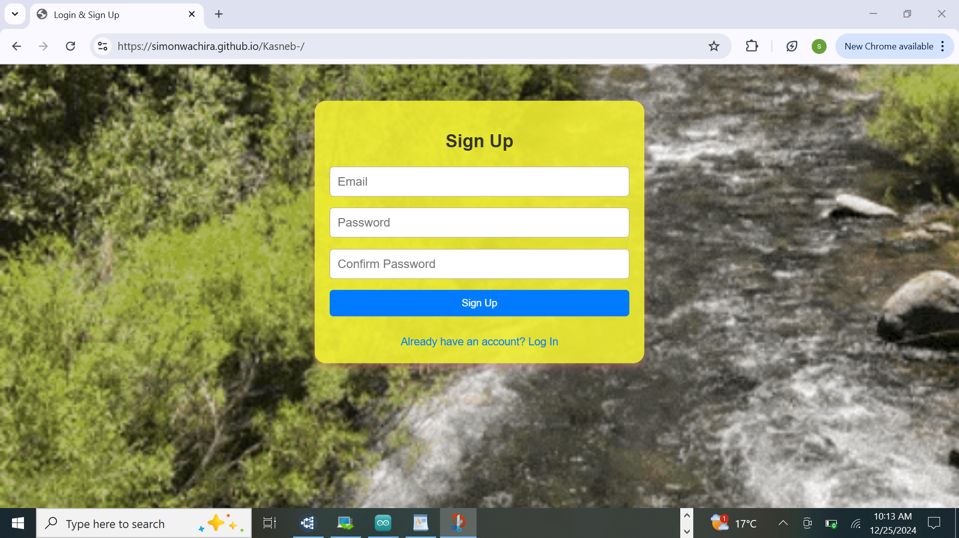

Figure 3.2.1.1 Secure User interface design of the User sign up

1. Log In
2. It allows users to access their accounts by inserting their email and passwords.
3. The log in form is designed on a floating form.
4. Users are supposed to click on log in button to access the payment page

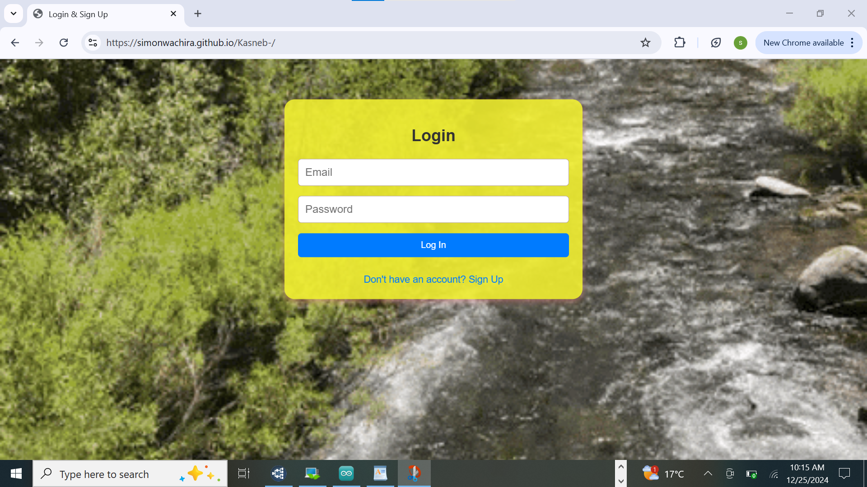

Figure 3.2.2 Secure User interface design of Log In

1. Payment page
2. It facilitates secure and easy payment processing
3. It’s designed on a floating form and styled the same way sign up and log in have been styled.
4. The users are supposed to initiate payment by inserting the phone number and the amount, then click on pay button.

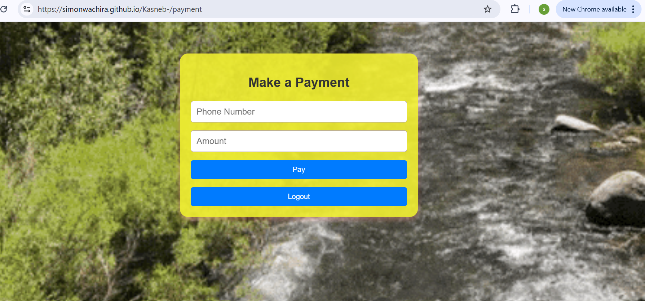

Figure 3.2.3 User Interface for Users Payment

1. Change password prompt

Once the users forget their password, they click on forget password link and redirected to correct emails used when signing in for password reset.

1. It helps User secure their accounts in case they genuinely forgot their accounts or suspicious people are trying to access the accounts. Email address proves identity of the User.
2. Users can use the same link to set New password of their choice.
3. Users click on OK button to submit their email and if not sure, they can cancel the request.

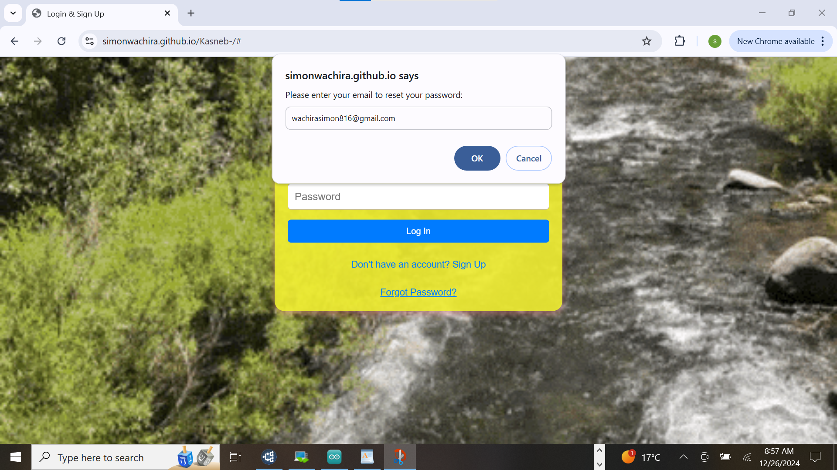

Figure 3.2.4 User Interface for Users forgotten password

**3.2.2 Styling of User Interface.**

* The background has been styled using a gif (river.gif)
* The form containers are designed and colored on yellow semi transparent background.
* The buttons are colored in blue

## **3.3 DATA STORAGE DESIGN**.

The data storage used here is MongoDB, this is a NoSQL database that provides flexibility, scalability and performance. It aligns with the system requirements for handling User Authentication, otp Verification, Transactions,Esp32Logs. Tis design aims to achieve Scalability, security, flexibility and performance.

From CMD this is the Database and collections for storing User Authentication, otp Verification, Transactions,Esp32Logs

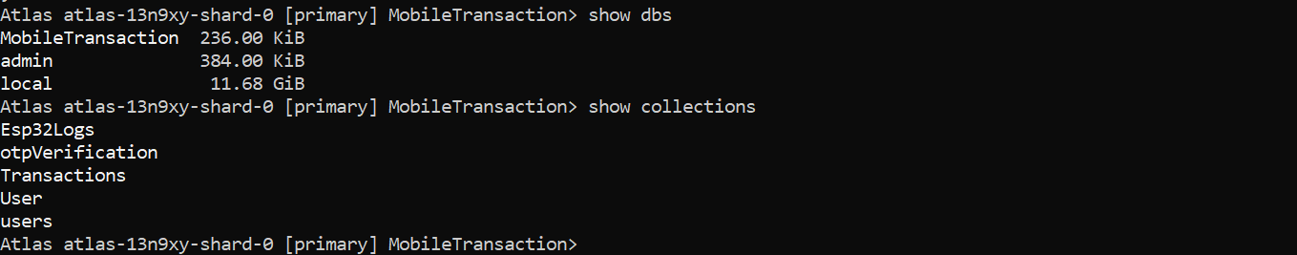

Figure 3.3.1 shows Available DBS and collections

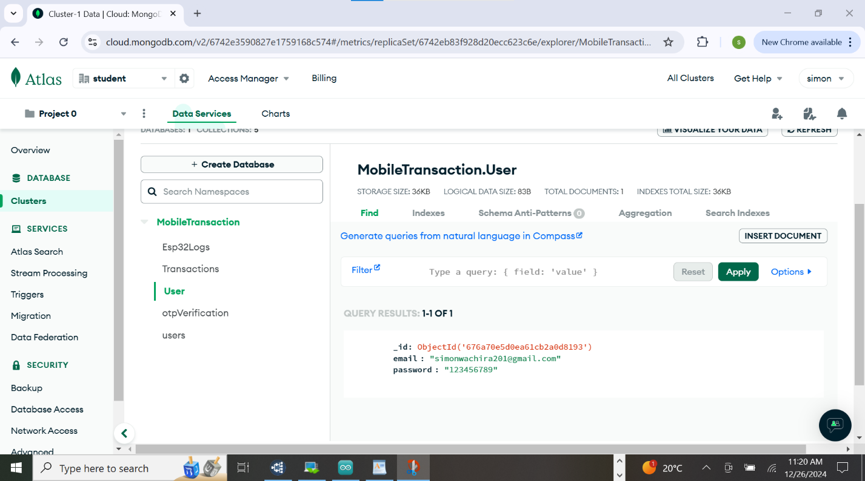

Figure 3.3.2 shows Mobile Transaction MongoDB storing User Authentications

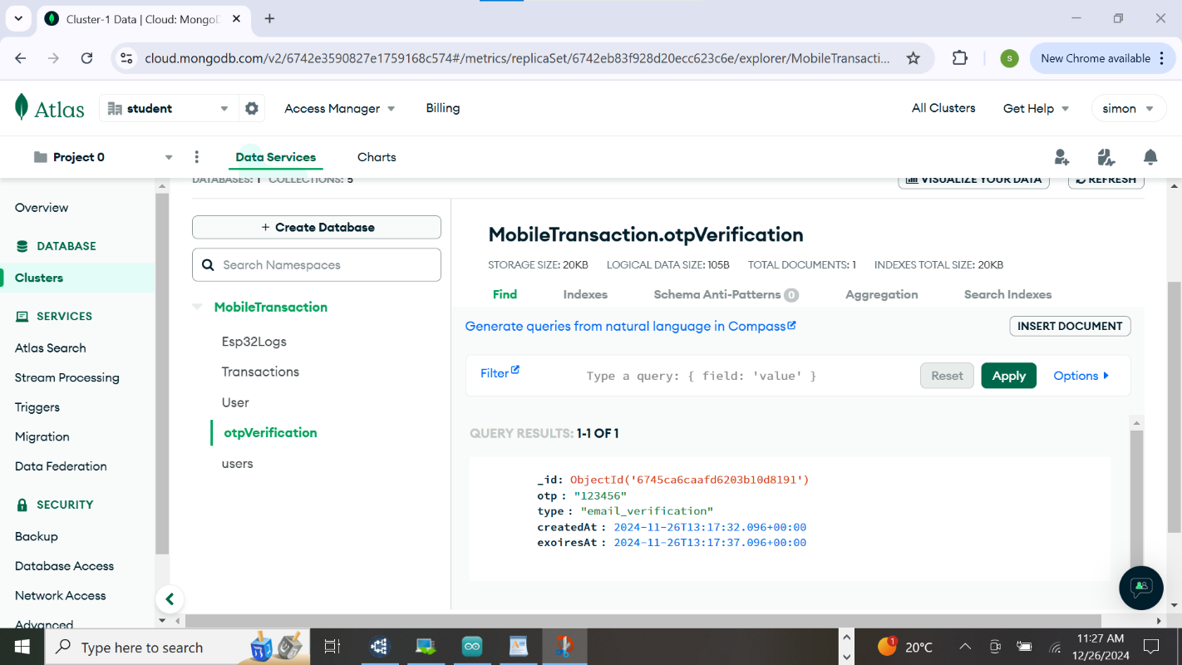Figure 3.3.3 Shows Mobile Transaction MongoDB storing otpVerification Collection

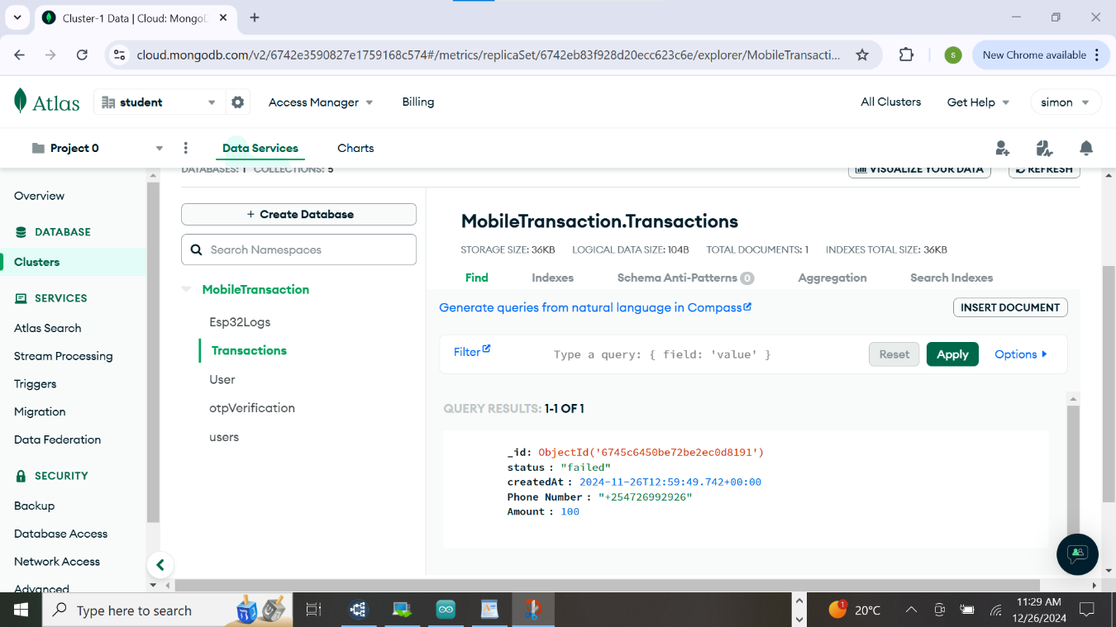

Figure 3.3.4 shows Mobile Transaction MongoDB storing Transaction Collection

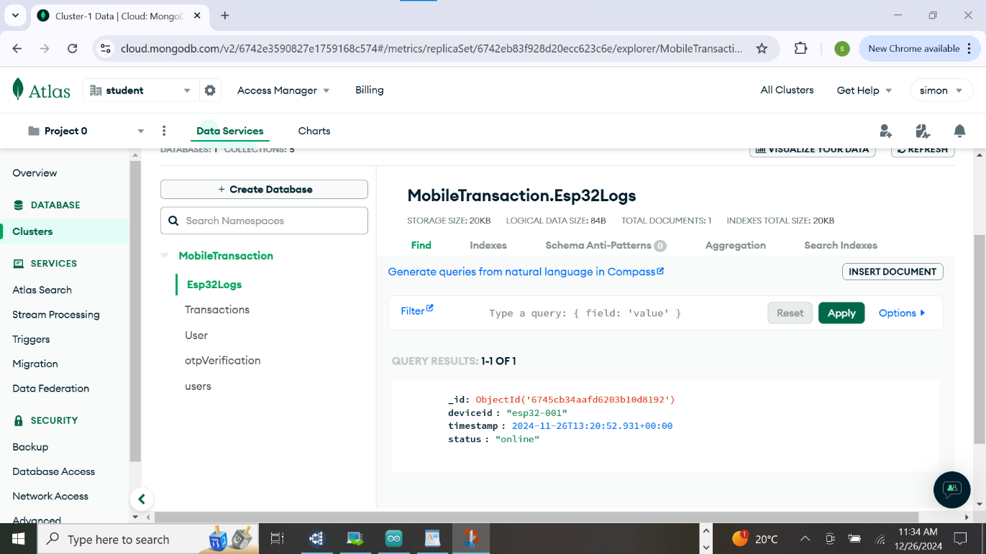

Figure 3.3.5 shows Mobile Transaction MongoDB storing Esp32 Collection

**3.4 (A) Implementation**

**3.4.1 WEB APP PROGRAMMING WORK**

After the system design was developed, on this phase it was to put the program to action. Top down approach was implemented. My codes were broken into smaller modules for easy debugging and troubleshooting .

The benefits realized from this approach were:

* Testing and Debugging is easier
* Codes are tested separately.
* Codes are easy to understand and manage.

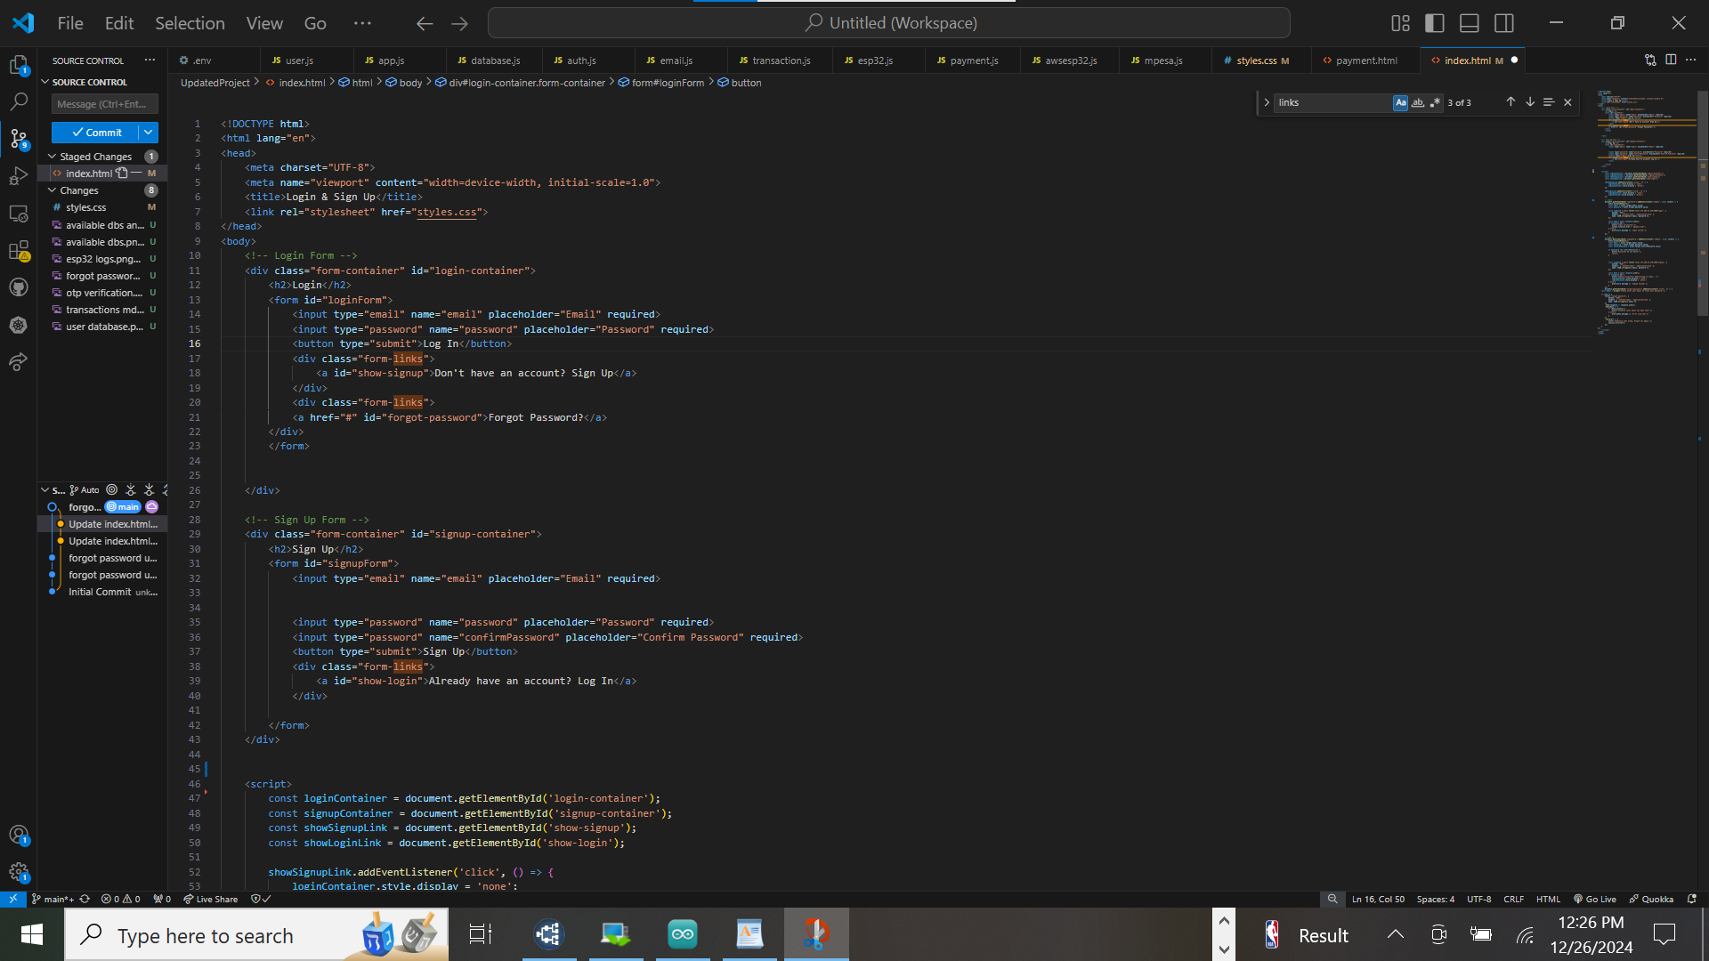

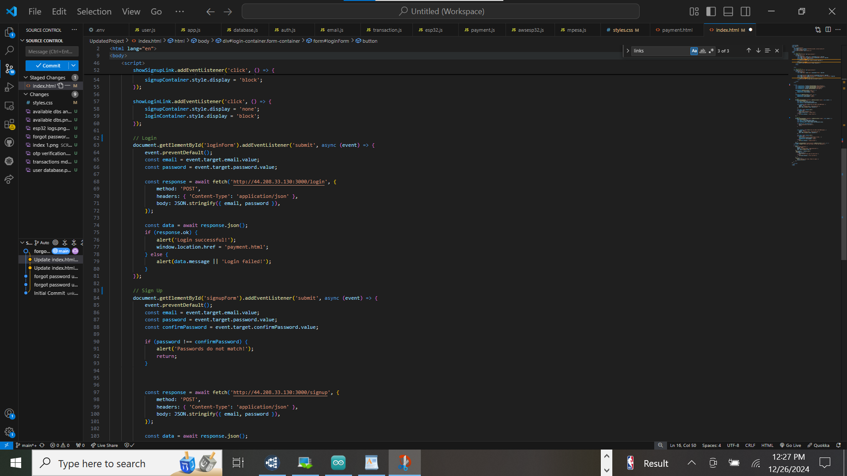

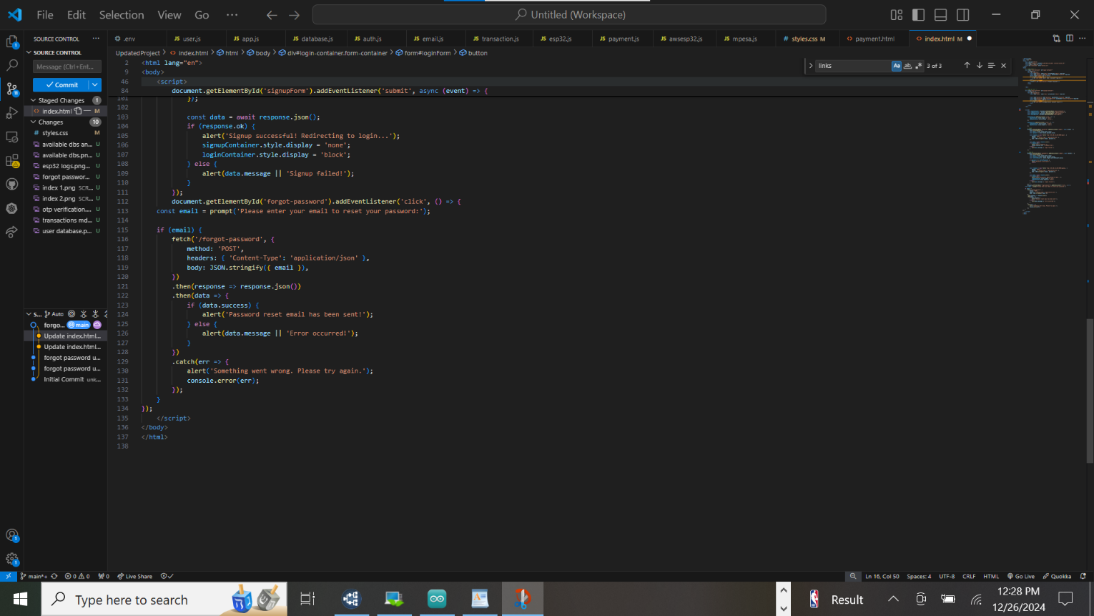

Figure 3.4.1 Shows HTML, Javascript for users Interface on sign-up, log-in and modify password

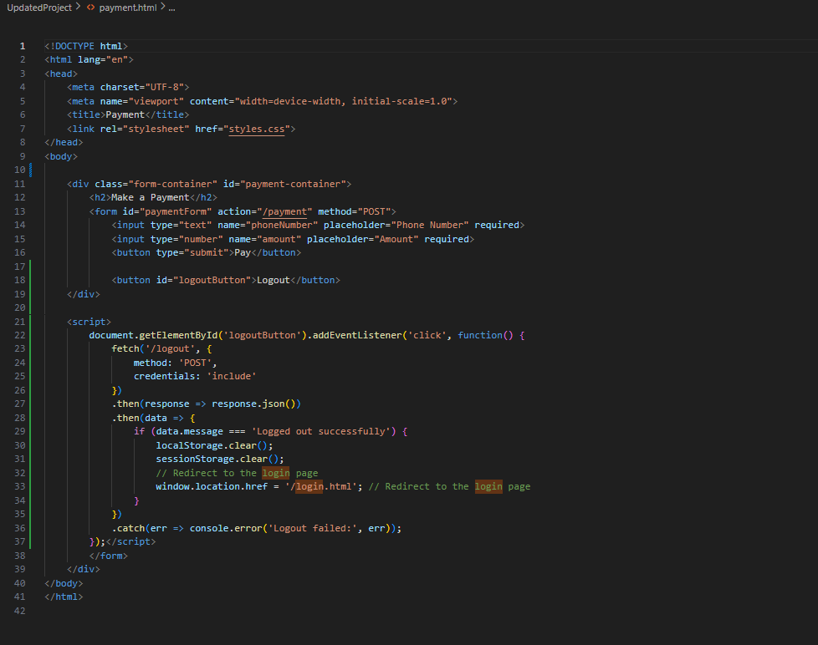

Figure 3.4.2 Shows html code Payment Interface and embedded JavaScript that allows users to make a payment and log out from the system.

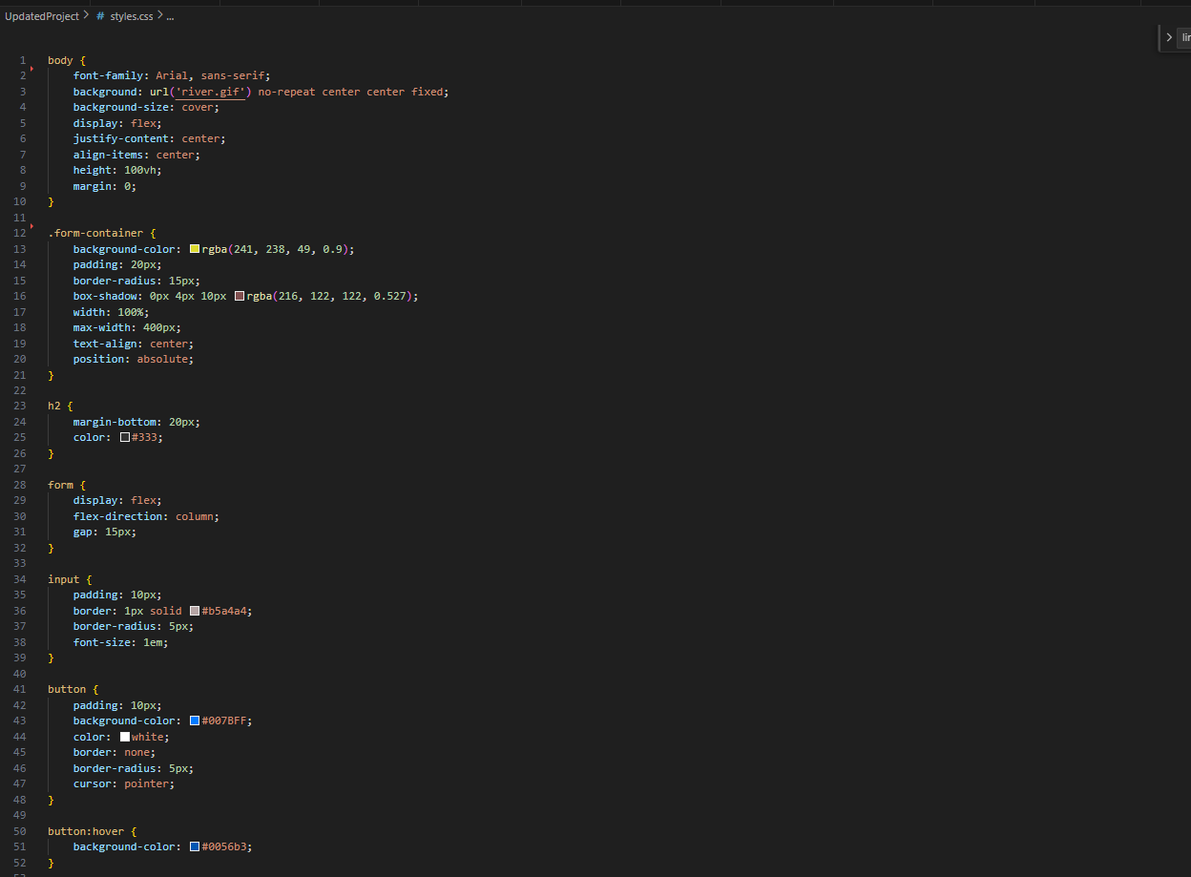

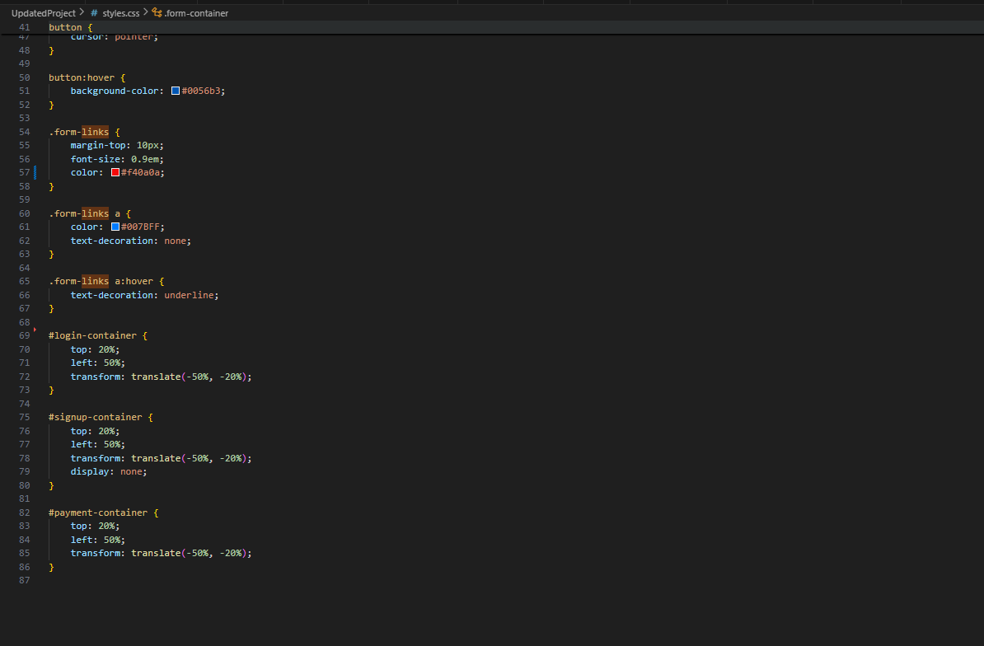

Figure 3.4.3 Shows CSS Styles

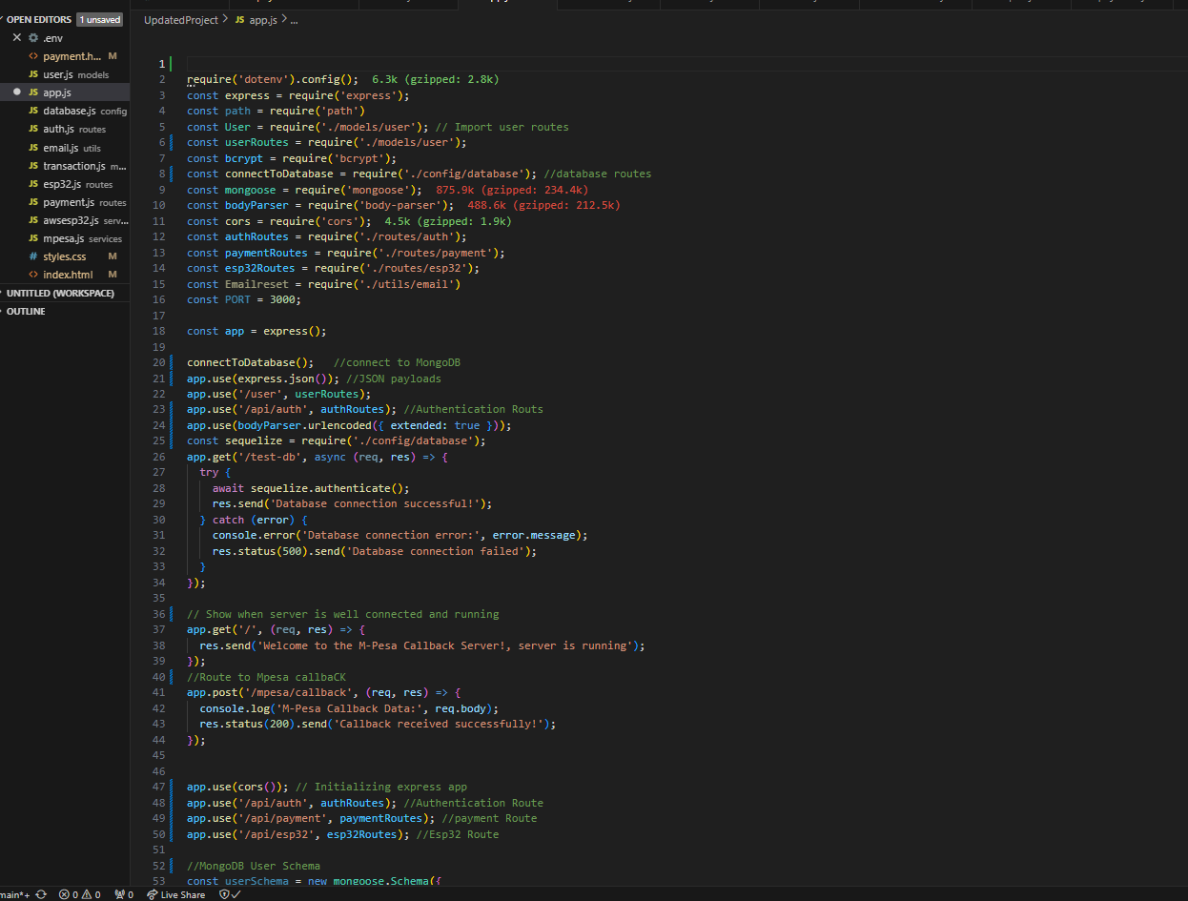

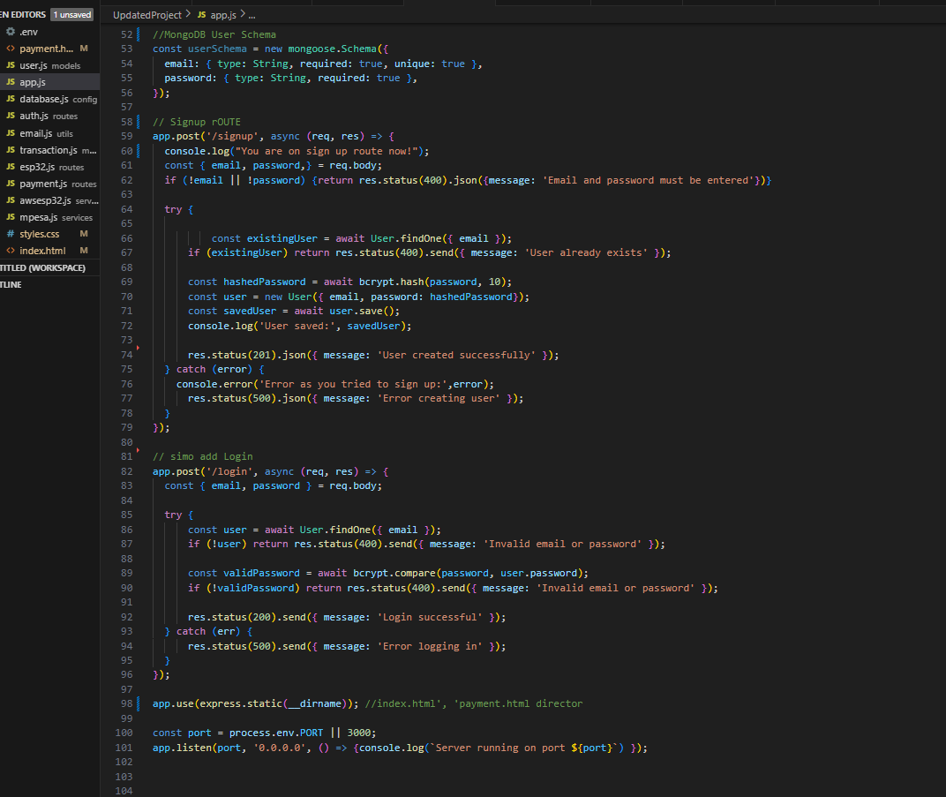

*Figure 3.4.4 Shows Node.js server code*. This code is a backend implementation for my web App which involves User Authentication, database connection, M-Pesa integration and Esp32

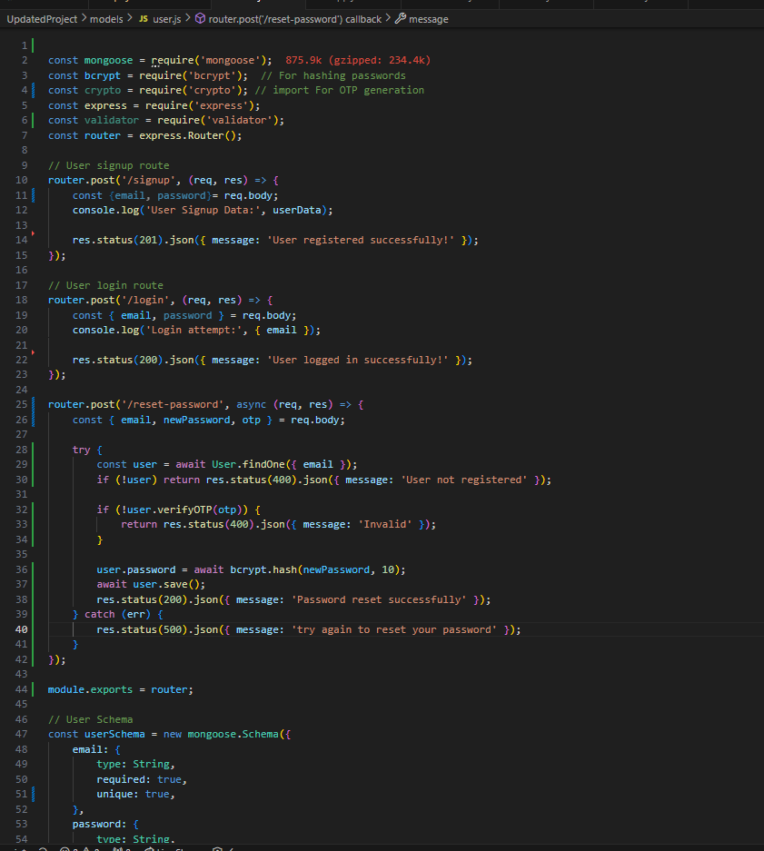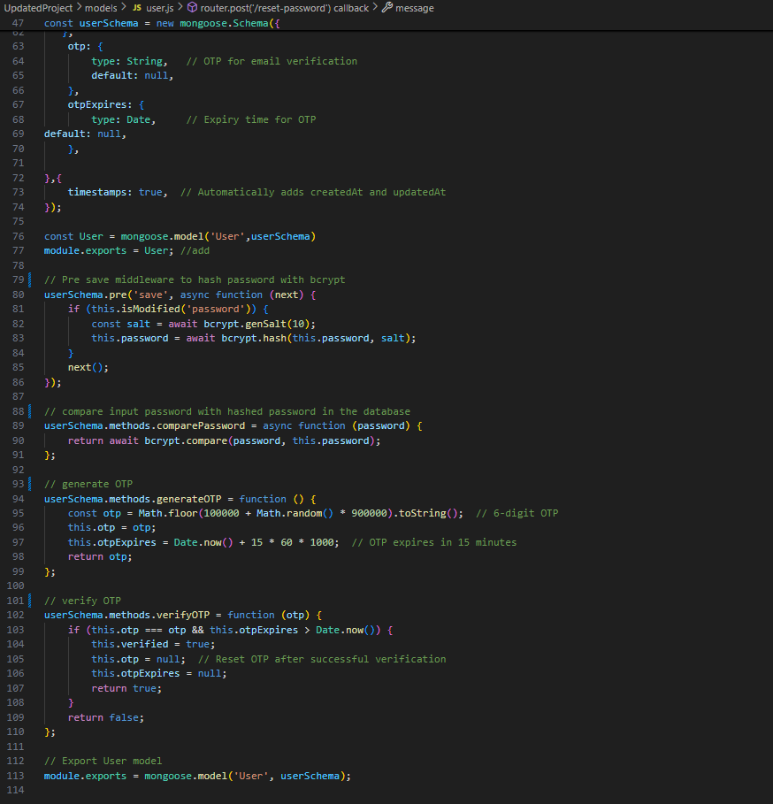

*Figure 3.4.5 shows user.js*: The code defines a user authentication module for Node js Web App using Mongoose (it defines a schema for storing user data in MongoDB). It has features like User Sign indicated with /signup: up and log in demonstrated using login route /login: and also for security purposes it demonstrate password hashing using bcrypt.

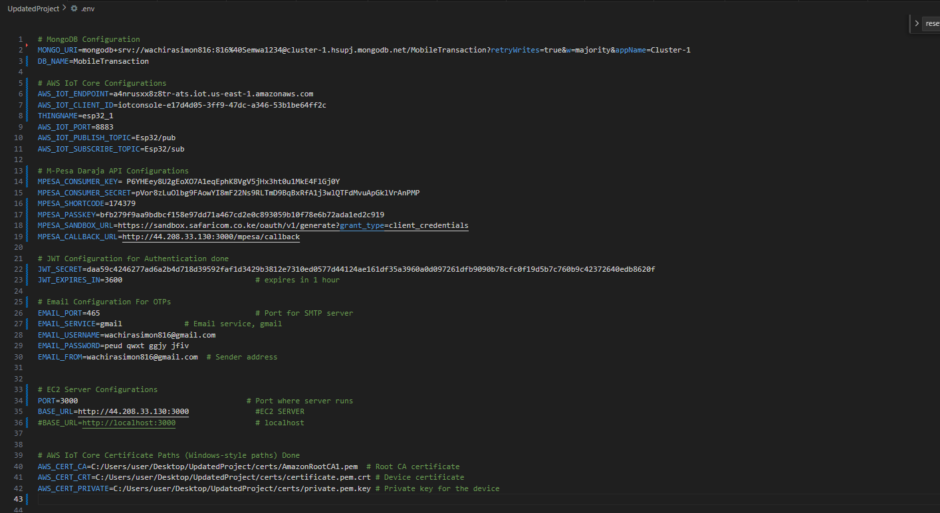

Figure3.4.6 shows environmental variables saved as .env on my code folder:

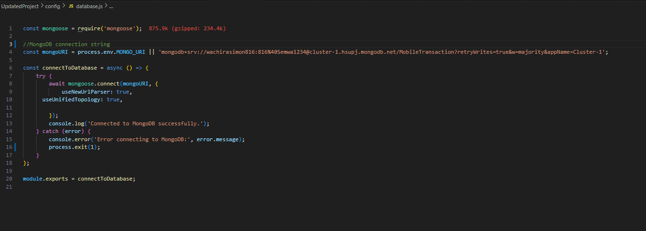

Figure 3.4.6 shows database.js: This code provides a connection to MongoDB using the mongoose library

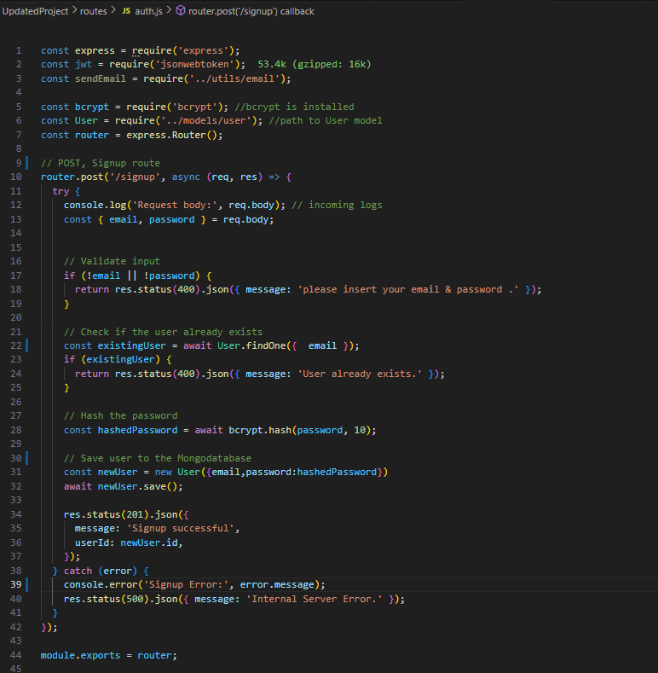

Figure3.4.7 Authorization code: this code handles user sign up functionality . It integrates express java script with Mongo database. It hashes users credentials using bcrypt.

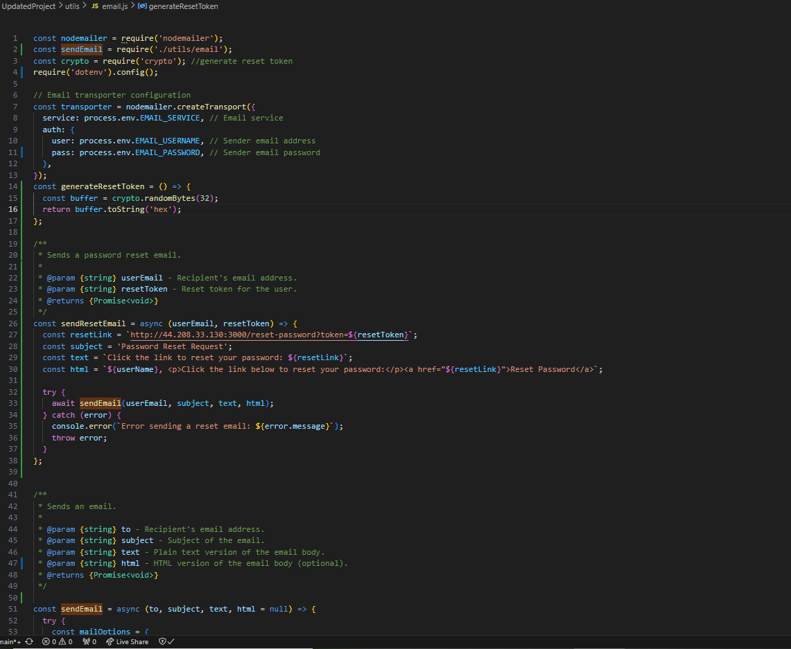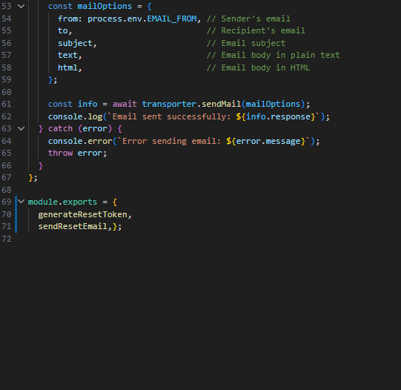

Figure 3.4.8 shows email.js: it’s used to facilitate a password reset system using Node.js. [7]

On this code I have imported nodemailer for sending emails , crypto for generating secure tokens. When a user requests a password change from the log in page. The system generates a unique token using generate Reset Token, this token is then sent to the user via email using (send Reset Email. )

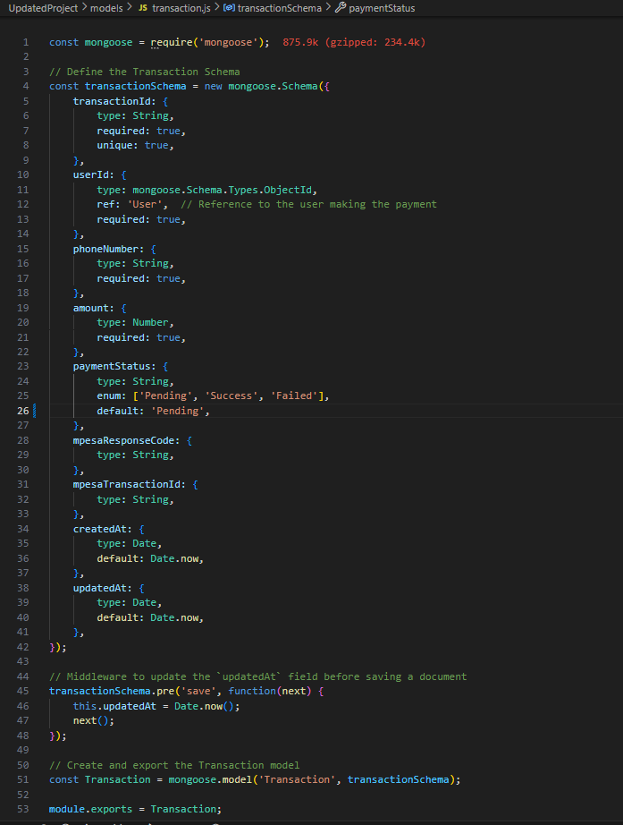

Figure3.4.9 shows Transaction.js: it defines the necessary fields for recording payment transactions

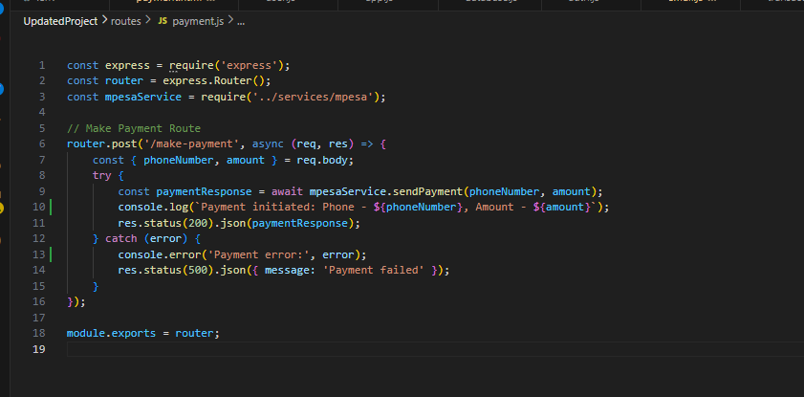

Figure 3.4.10 shows payment.js : It is designed to handle payments via Mpesa.

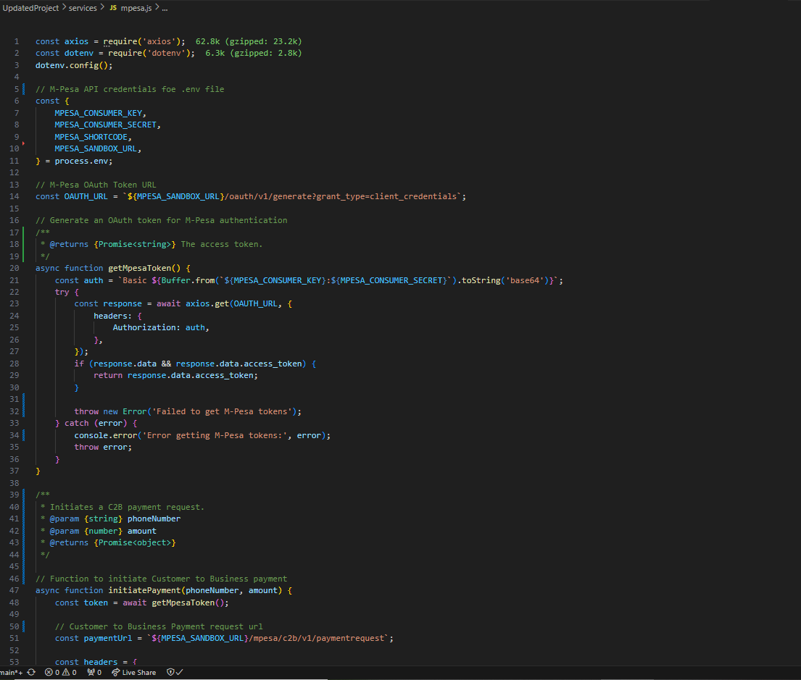

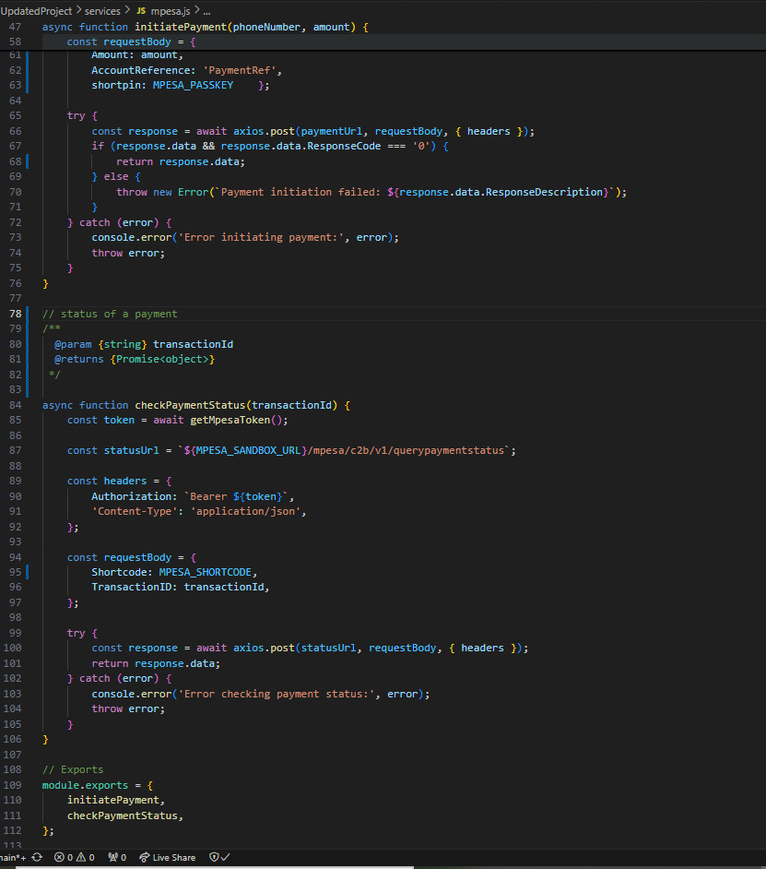

Figure 3.4.11 Mpesa.js : This interacts with mpesa Api to handle payment initiation and payment status check. I am using (dotenv) to import most of mpesa information as they have been saved in environmental variables.

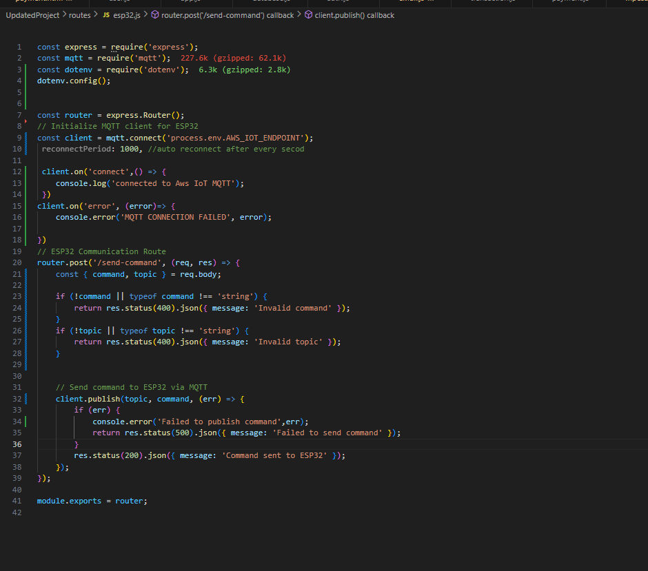

Figure 3.4.12 shows ESP32.js: This code defines express router for sending MQTT messages ESP32 IoT device. I have imported mqtt library to connect to AWS IoT Core MQTT broker. The device have been set to reconnect after every second.

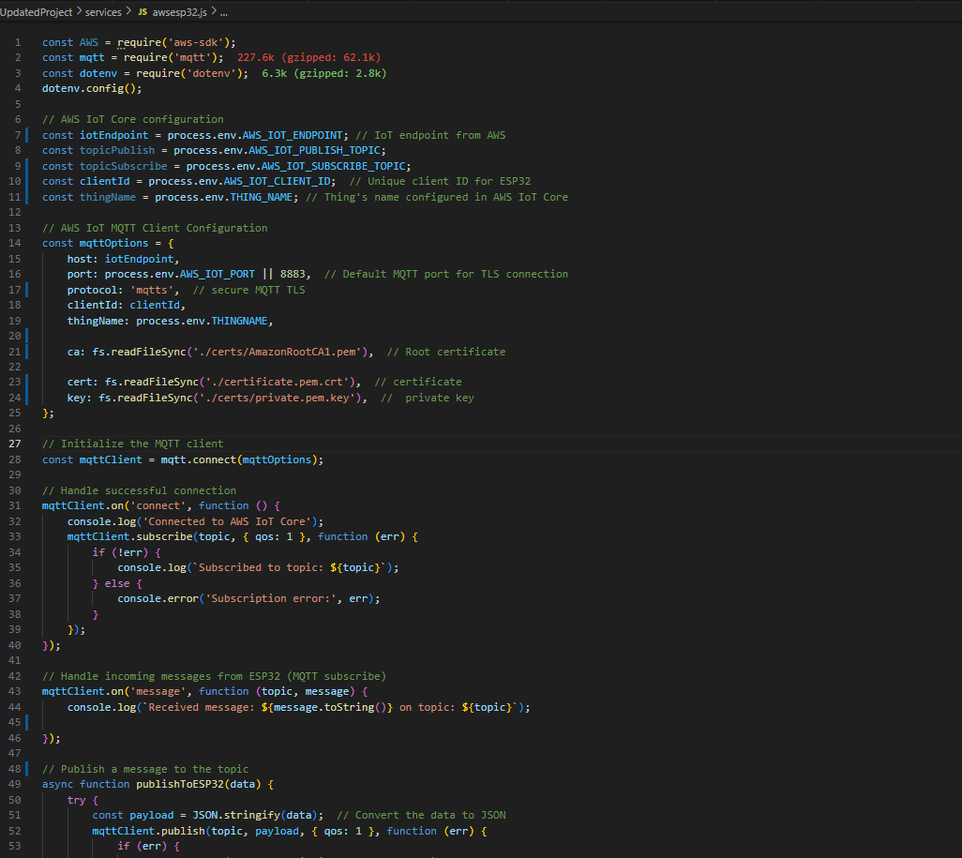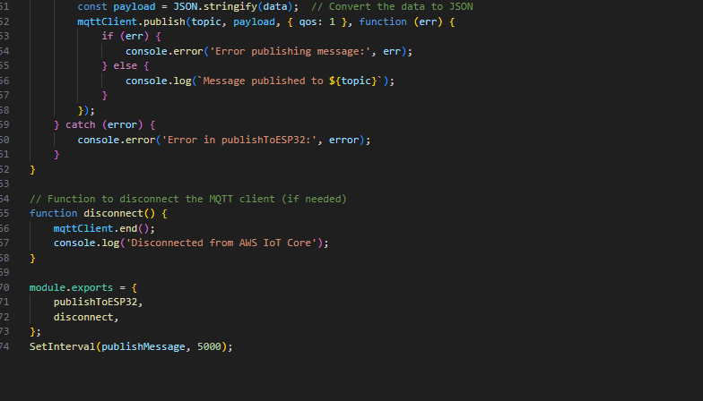 Figure 3.4.13 shows : This code establishes secure communication with AWS IoT Core using MQTT. It facilitates subscribing to topics to receive messages from ESP32 and publishing messages to User’s device.

**3.4 B) ESP32 CONFIGURATIONS USING ARDUINO**

1. 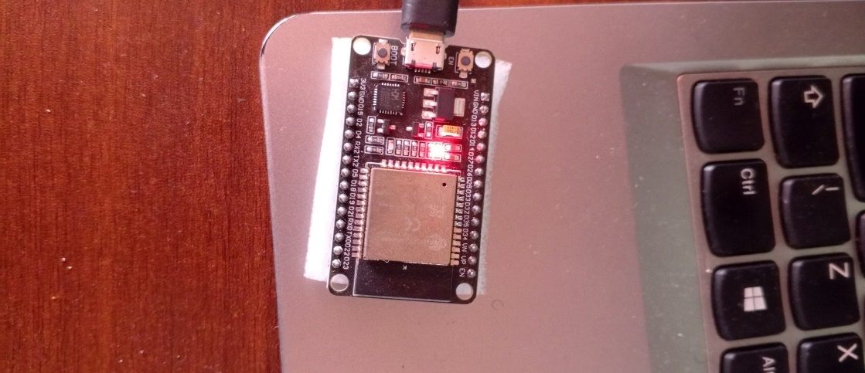

Figure 3.4 (i) shows connected ESP32 Device : This is a highly integrated low power microprocessor with built in Wi-Fi and Bluetooth capabilities, this makes it most preferred device for IoT applications.

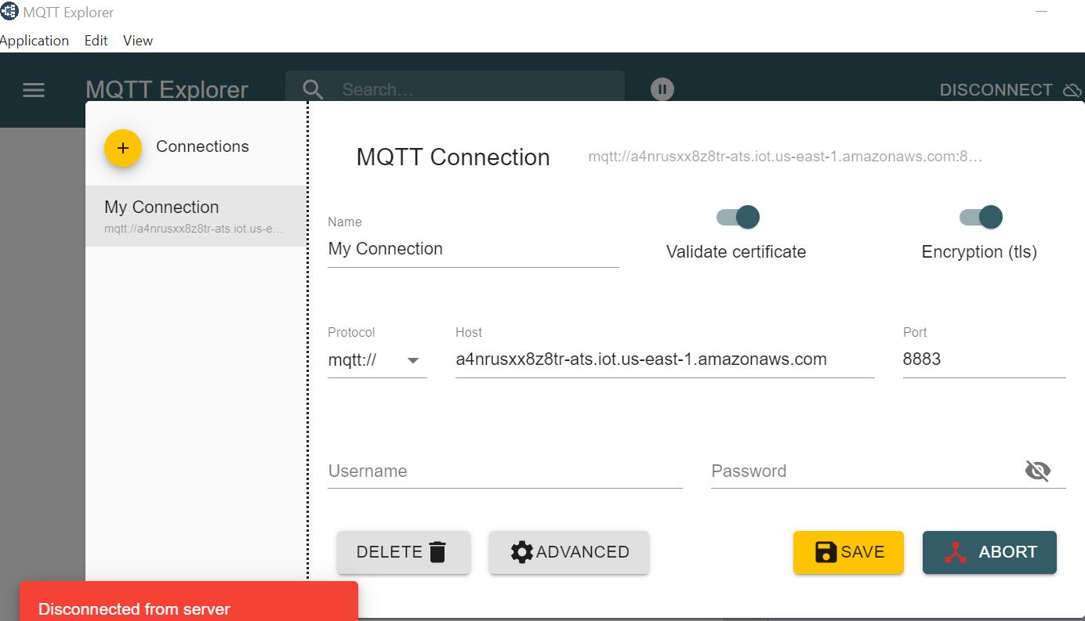

*Figure 3.4 (a) shows MQTT Explorer interface*: MQTT Explorer is a graphical tool for interacting with an MQTT broker in AWS.

**Features of ESP32**

* **Connectivity: -** Wi-Fi – once configured with the correct SSID and password it connects automatically**.**
* **Security:** - Supports TLS for secure communication.
* Works seamlessly with Arduino Development Environment

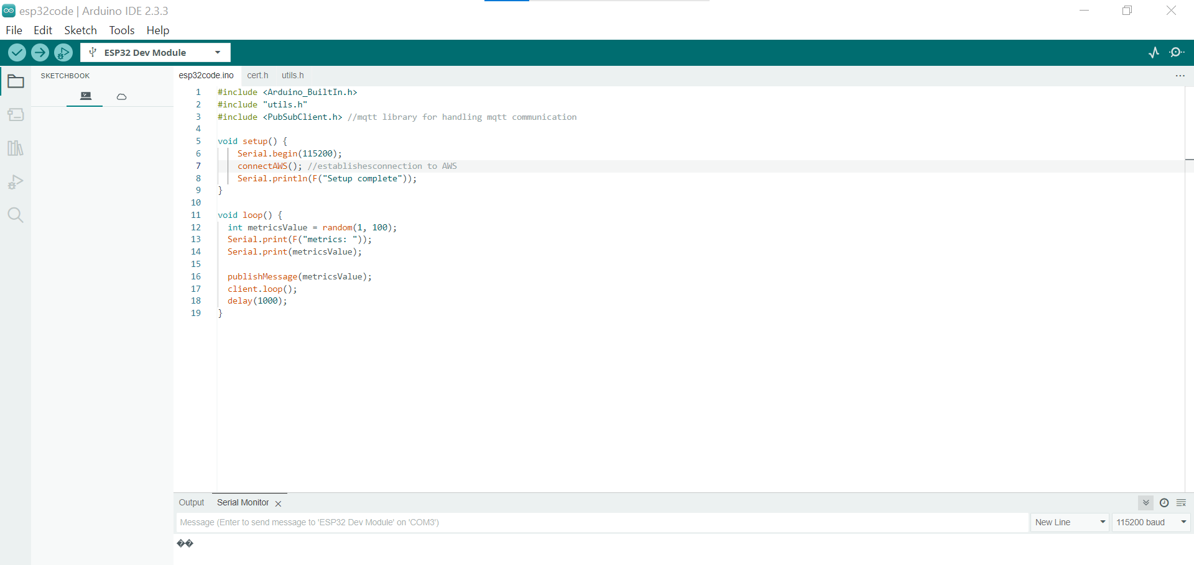

Figure 3.4 (ii) shows(esp32code.ino) ESP32 Code configuration.

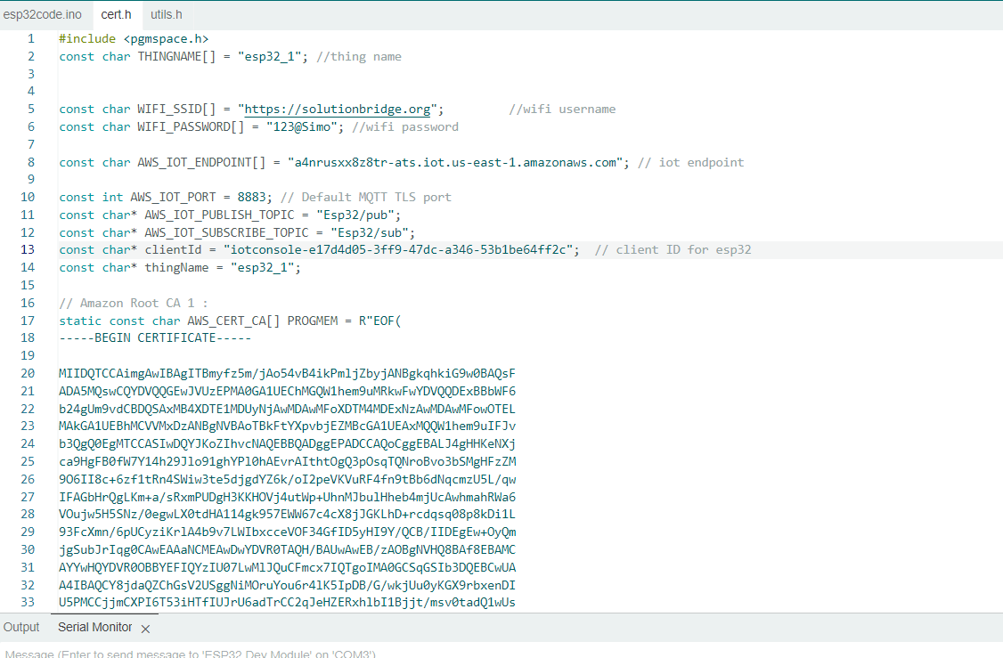

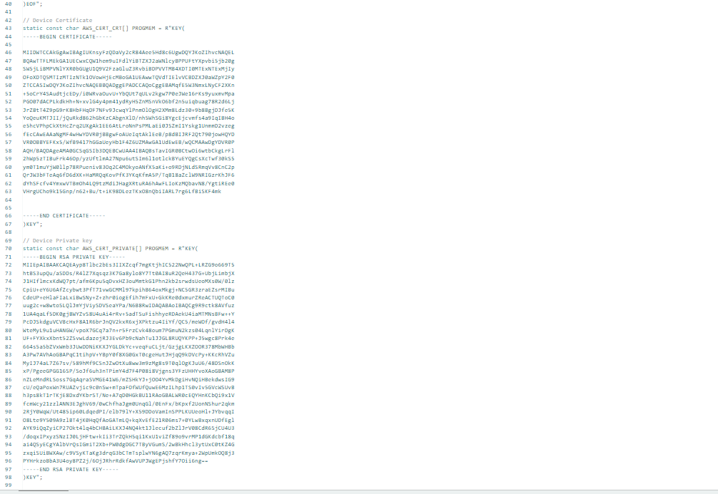

Figure 3.4 (iii) shows cert.h code : it contains configurations for the ESP32 to securely connect to AWS IoT Core using MQTT Over TLS, the code also contains Certificates for the device.

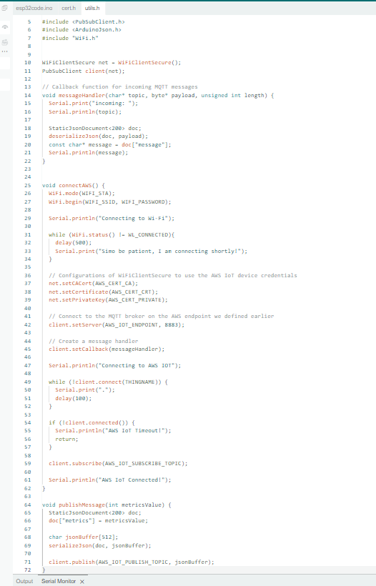

Figure 3.5 (iv) utils.h, it used in configurations for ESP32 to AWS IoT Core using MQTT over TLS

1. **TESTING**

Three types of testing were done on the developed system.

### 4.1 Unit testing

In unit testing two approaches were applied.

1. Black box testing. The objective of this test was to ensure that only valid inputs were entered into the system, eg ensure that users insert the valid log in credentials (email and password) .
2. White box testing. This was conducted to compare the written code and the errors that may have occurred when implementing the Application.

4.2 Integration testing

In integration testing four approaches were applied.

1. User interface testing - On this system was done to verify that all User Interface components are well integrated and function as expected ensuring a smooth and logical user experience.
2. Button Integration – was conducted to test that all the buttons on the sign up, login and payment page work as expected.
3. Test interaction between sign-up , log in and payment page was conducted to enhance a cross-module functionality.
4. Error handling – Test for proper display of error messages when unexpected inputs or interaction occur.

### 4.3 System testing

Security testing, Requirement testing, Performance testing, Usability testing was done.

1. Performance testing- This was conducted to check system stability, measured system response times and error rates.
2. Requirement testing – This was conducted to ensure that the system meets all the stated requirement eg. For users to log in they must insert their valid emails and passwords.
3. Security testing – This was conducted to ensure that the users data are well protected and prevent unauthorized access. Eg users can’t access payment page without creating accounts.
4. Usability testing – for a first time user. They should sign up a new account, navigate to payment and log out.

1. **MAINTENANCE (technical) MANUAL**

Technical manual for Mobile Payment System, will help System Admin and Technical support teams to easily navigate within the system.

**5.1.1 PURPOSE**

This manual provides the guidelines for the maintenance and operation of the mobile payment system, ensuring security and data integrity.

**5.1.2 SCOPE**

This manual covers the entire system including the backend API, ESP32, MongoDB, Web App, and integration with payment gateways like M-Pesa.

**5.1.3 AUDIENCE**

This manual is intended for:

* System Admins
* Technical support Teams

**5.2 SYSTEM OVERVIEW**

**5.2.1 System Architecture**

The mobile payment system is a secure , scalable architecture based on an IoT Cloud Integration model. It consists of:

* Frontend : A web App built with HTML5, CSS and Javascript.
* Backend: An API that handles payment processing, Authentication, integration with M-Pesa
* IoT Device : ESP32 device connected to AWS IoT Core for communication with the backend.
* Cloud Services : AWS EC2 for authentication and secure communication with the back end.

**5.2.2 Components and Technologies**

* Frontend : HTML5, CSS, JavaScript.
* Backend : Node.js,Express.js Mongoose for MongoDB integration
* IoT : ESP32, AWS IoT, MQTT
* Payment Gateway: M-Pesa Integration with Daraja API.
* Database : MongoDb for User, Transaction, OTP, Esp32 data storage

**5.3 MAINTENACE OBJECTIVE**

The major objectives for maintenance are:

* Maximizing system uptime: ensure that’s all services are available and performing as expected.
* Maintaining security: Apply patches and monitor for vulnerabilities to secure sensitive data.
* Ensuring Data Integrity: Maintain accurate and consistent User and transaction data.

**5.4 Regular Maintenance Tasks**

**5.4.1 Software Updates**

* O**bjectiv**e: ensure that all system components are running the latest stable versions. bcrypt library should be running on the updated version for security purposes.
* T**asks**: Check for updates to the backend system (Node.js, libraries and API)
  + Regular update for ESP32 and AWS SDKs
  + Apply security patches to MongoDb
* **Tools:**
  + Use package managers like npm for update

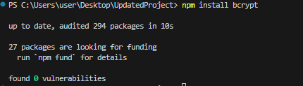

***Figure5.4.1 shows bcrypt update on cmd***

* + AWS SDK IoT and backend integration updates.

**5.4.2 Hardware checks**

* Check status of ESP32 and their network connectivity to AWS IoT Core.

This can be done by pinging the IoT Ends Point on AWS

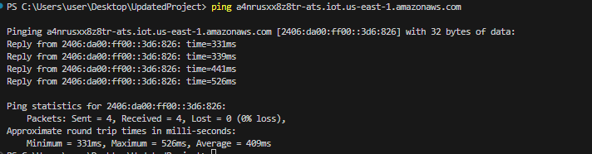

Figure5.4.1 shows ping to the AWS ESP32 EndPoint

* Test the performance of EC2 Server running the backend and database, this can be achieved by using tools postman to check the API end Points.

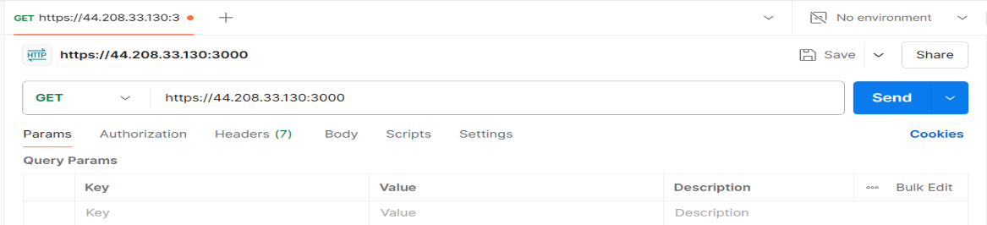

Figure 5.4.2 shows get method on post man to test the ec2 server and API endpoints.

Test if MongoDB is connected from the server.

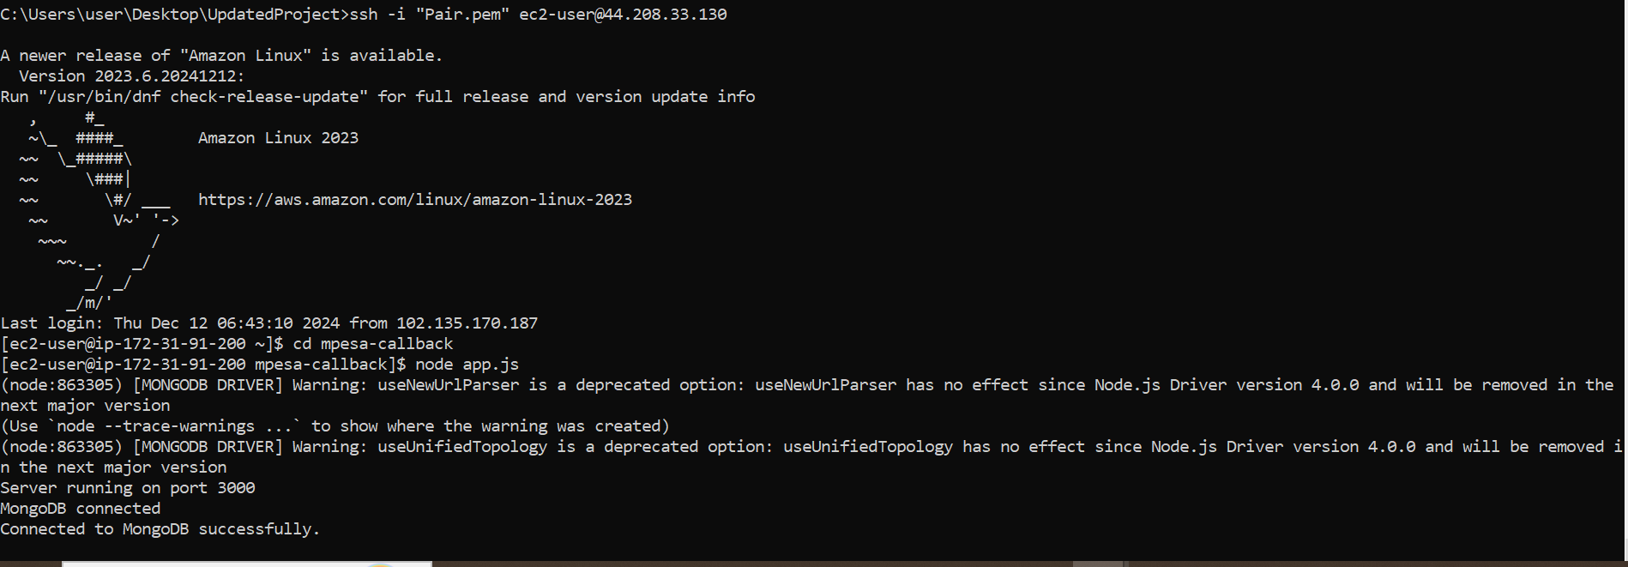

Figure 5.4.3 shows a console output from the server connection to the MongoDB

**5.4.3 User Data Backup**

Safeguard system data through periodic backups to ensure quick restoration in case of failure

* Backup the Data to MongoDB Regularly

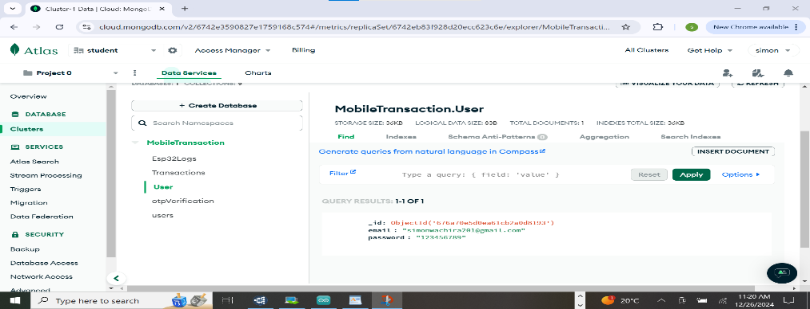

Figure 5.4.4 shows updated users on the DataBase

**5.4.4 Security Updates**

Maintain the security of the system by applying timely updates and monitoring for vulnerabilities.

**5.5 TROUBLESHOOTING PROCEDURES.**

**5.5.1**

* **ESP32 Not connecting**
* Check Wi-fi connectivity.

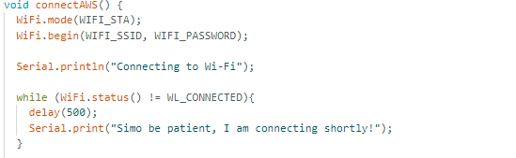

*Figure 5.4.5 shows code to check if in deed the device is connected*

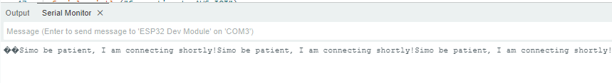

*Figure 5.4.6 shows output of successful connection*

* Validate device certificates
* **Payment Gateway Failure**
* Verify M-Pesa API status

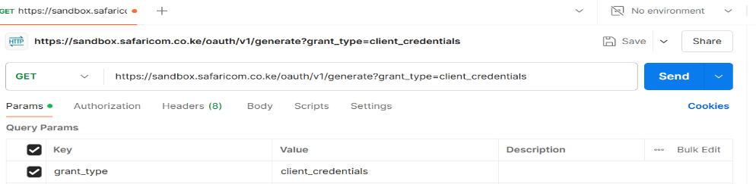

*Figure 5.4.7 shows MPESA API test using Postman*

**5.5.2 Diagnostic Tools**

* Backend logs (Node.js and Express) for error messages
* Ping for network and MQTT Explore for troubleshooting ESP32
* MongoDB Atlas monitoring 

*Figure 5.4.7 shows cmd command to monitor available database and collection*

**5.5.3 APPENDIX**

**References:**

* **AWS IoT core Documentation** [**https://docs.aws.amazon.com/iot/latest/developerguide/**](https://docs.aws.amazon.com/iot/latest/developerguide/)
* **M-Pesa API Documentation** [**https://developer.safaricom.co.ke/Documentation**](https://developer.safaricom.co.ke/Documentation)
* **MongoDB Documentation**

[**https://www.mongodb.com/docs/**](https://www.mongodb.com/docs/)

1. **USER MANUAL**

**6.1 Introduction**

**6.1.1 Purpose**

This user manual provides step by step instruction on how to use the mobile payment system to ensure secure user experience.

* + 1. **Overview**

**The system allows users to :**

* Create accounts by inserting their correct email and passwords, repeat the same password to confirm its correct**.**
* Log in Securely by inserting their credentials used during sign up (email and password) if the users forget their password they can reset it by clicking the reset password link (blue in color**)**
* Make payment using phone number and preferred amount to be paid
* Log out from the system for enhancing the security.
  1. **System requirement**
* To use the system, users should be connected to the internet
* Updated web browser eg Chrome, Firefox.
* An email address to receive the OTPs when resetting their password.
* Access the M-PESA.
  1. **Getting Started**

**6.3.1 Accessing the system**

* Open a web browser on your device.
* Load the URL to access the system



***Figure 6.3.2 to access the system***

* + 1. **Creating an Account**
* On the home page , insert email, password and confirm password.
* Click on sign up.

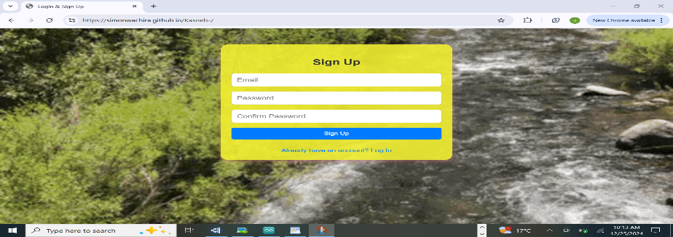

*Figure 6.3.2 user sign up page*

* + 1. **Logging In**
* Enter your registered email and password
* Click on log in.
* You will be directed to payment page.

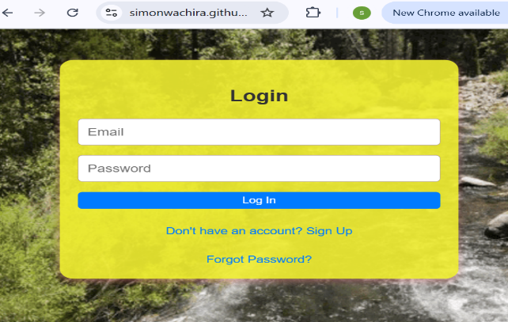

* + 1. **Change forgotten password**
* Click on forgot password
* Enter your email

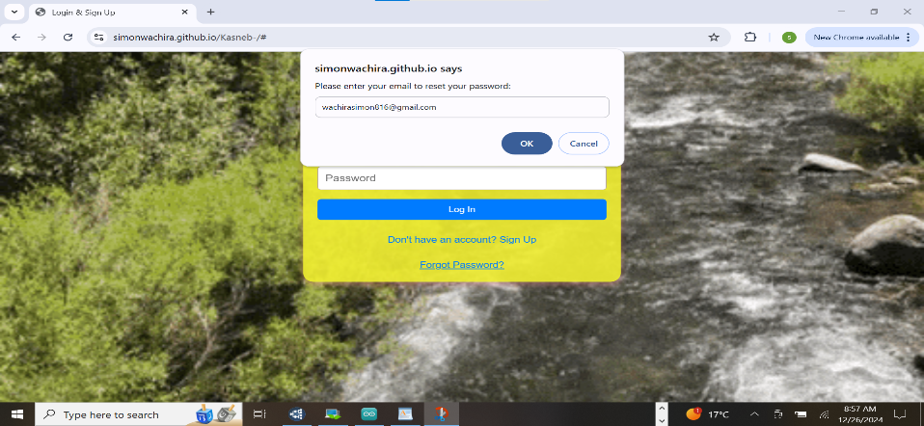

*Figure 6.3.4 shows forgotten password update*

* Click the link to reset your password
  1. **USING THE SYSTEM**

**6.4.1 Making Payment**

* After logging in you will be directed to Payment page
* Insert the phone number and the amount
* Click pay button to initiate the payment.



***Figure 6.4.1 showing payment page.***

* + 1. **logging out**
* Once done with the payment, click on log out button for security purposes.

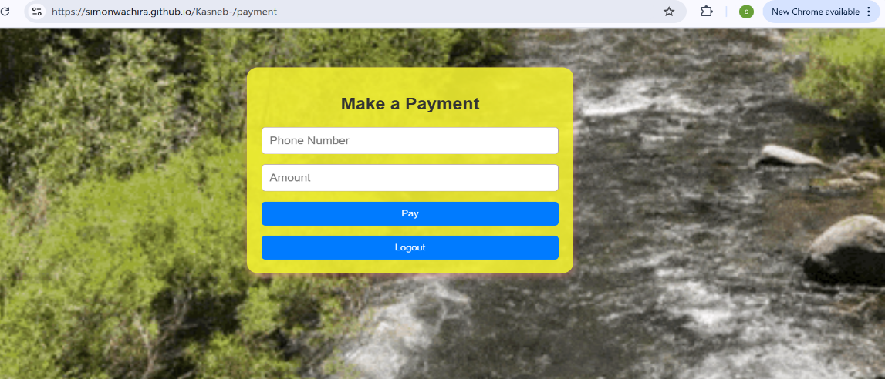

*Figure 6.42 shows logout button after payment process*

* This will securely end your session and redirect you to the log in page
  1. **Troubleshooting**
* **Can’t log into the system.**
* Ensure you are using the correct email and password you used to sign up. Unregistered credentials will not access the account.
* If you forgot your password use the forgot password option to **reset** it.
* **Payment not processed**
* Verify the phone number and amount are entered.
* Check if you are connected to the internet.
* Make sure you are registered with M-pesa.
* **Failed Logout**
* Refresh the page and try to log out again.

1. **Frequently asked Questions.**
2. **How secure is my data?**

Your data is encrypted during transmission and securely stored in the database. We use secure TLS for communication

1. **Can I access the system on mobile phone?**

Yes, the system works on mobiles phones

1. **What happens if I forgot my password**?

Use forgot password feature on the log in page to reset the password, a link will be sent to your email for resetting the password.

1. **CONCLUSSION**

The development of the mobile payment system (A Secure and Scalable IoT Cloud Integration Architecture for Mobile Payment) has almost met all the key objectives outline in the project proposal. The system itself is not fully complete as more functionalities will have to be added and improved. The project demonstrated AWS IoT Core for cloud Integration and M-Pesa seamless financial transactions. The implementation of TLS encryption to ensure data integrity and security. The user interface provides a straightforward experience for users sign up, log in modify their forgotten passwords and make payment. Testing including integration, system testing confirmed system functionality and security. This only serves as a practical Application but majorly as a foundation of more research on secure IoT based payment systems. Future there would be need for advancement to mobile Application as we are living in a digital era where smartphones are almost used by everybody. Future enhancements could explore Artificial Intelligence techniques for fraud detection, integration with other payment gateways like Airtel Money . Those are few of the many future improvements which can be made to improve this system.

* + - 1. **REFERENCES**

1. [1] The Relationship between National payment systems and the Economic growth in Kenya G Muiruri 2015•erepository.uonbi.ac.ke

[2] "Security and Trust in Africa's Digital Financial Inclusion Landscape," Carnegie Endowment for International Peace. [Online]. Available: https://carnegieendowment.org/research/2024/03/security-and-trust-in-africas-digital-financial-inclusion-landscape. [Accessed: Dec. 14, 2024].

[3] Adoption of **mobile payments**in **Kenyan**businesses: a case study of small and medium enterprises (SME) in **Kenya**

EO Otieno - 2015 - erepository.uonbi.ac.ke

[4] "Kenya National Payments System Vision and Strategy 2021 - 2025," Central Bank of Kenya. [Online]. Available: https://www.centralbank.go.ke/wp-content/uploads/2020/12/CBK-NPS-Vision-and-Strategy.pdf. [Accessed: Dec. 14, 2024].

[5] "Five Strategies for Mobile-Payment Banking in Africa," Boston Consulting Group. [Online]. Available: https://www.bcg.com/publications/2020/five-strategies-for-mobile-payment-banking-in-africa. [Accessed: Dec. 14, 2024].

[6] Lightweight authenticated-**encryption**scheme for **internet of things**based on publish-subscribe **communication** A Diro, H Reda, N Chilamkurti, A Mahmood

[7] Authentication **and**authorization **in**modern web apps for data security **using**Nodejs **and**role of dark web P Pant, AS Rajawat, SB Goyal, P Bedi, C Verma